ENERGYSCAPE:Multi-Seasonal Mathematical-Computational Framework for Predictive Energy Management and Carbon Reduction

In Partial Fulfillment of The Requirements of the
School Science and Technology Fair 2026

JOVIE ERMA S. ATON
MARIONNE JOY A. BESAS
DAMERAE A. ZAPATA
JHOANNA PEARL C. BASA
MHELMAR LAGEPLEP
Proponent/s

SAMY O. BORJE
Research Adviser

August 2026

ENERGYSCAPE:Multi-Seasonal Mathematical-Computational Framework for Predictive Energy Management and Carbon Reduction

Jovie Erma S. Aton, Marionne Joy B. Besas, Damarae A. Zapata, Jhoanna Pearl C. Basa, Mhelmar Lageplepª; Samy O. Borje^{b}
jovieermaaton5@gmail.com, zapatadamerae@gmail.com, jhoannapearlcorrebasa@gmail.com, mhelmarie123@gmail.com ª; samy.borje@deped.gov.ph^{b}
Abra High School, Bangued, Abra 2800

Abstract
This study developed ENERGYSCAPE, a multi-seasonal mathematical modeling framework for forecasting, quantifying, and optimizing electricity consumption in An-anaao Integrated School and La Paz Integrated School. It aimed to forecast monthly electricity consumption, evaluate the accuracy of the forecasting model, characterize seasonal consumption patterns, quantify the contribution of major electrical loads, and determine an optimized electricity-consumption level through conservation analysis. Historical monthly electricity-consumption and billing data from 2021 to 2025 were analyzed using descriptive statistical methods, graphical analysis, and the Exponential Smoothing (ETS) forecasting model in Microsoft Excel. The forecasting performance was evaluated using the Mean Absolute Percentage Error (MAPE) and Root Mean Squared Error (RMSE). Energy consumption attributable to major electrical loads was estimated using rated power, quantity, operating hours, and operating days, while mathematical conservation scenarios were evaluated to determine potential reductions in electricity consumption and associated costs.
Results showed that both schools exhibited seasonal variations in electricity consumption corresponding to the Philippine seasons, with electricity consumption generally increasing during the wet season and decreasing during the dry season. The ETS model produced low MAPE and RMSE values, indicating reliable forecasting performance. La Paz Integrated School exhibited a higher projected electricity demand than An-anaao Integrated School. The energy-load assessment identified the major electrical contributors to estimated electricity demand, while the conservation and optimization analysis quantified potential energy and financial savings under alternative reduction scenarios subject to defined operational constraints. The findings demonstrate that integrating multi-seasonal forecasting, energy-load quantification, and mathematical optimization provides a quantitative basis for establishing electricity-conservation priorities and managing energy demand in educational institutions.
Keywords: electricity consumption, mathematical modeling, multi-seasonal forecasting, Exponential Smoothing, energy-load quantification, mathematical optimization, energy conservation.

Acknowledgement
The researchers would like to acknowledge and extend their warmest thanks to their research adviser, Sir Samy O. Borje, who guided them and made this project possible. His time, patience, and guidance gave them full motivation and carried them throughout the experiment.
The researchers are deeply grateful to their parents for their financial support, encouragement, and unwavering belief in their capabilities. Their guidance and generosity have served as a constant source of motivation for them and the reason they have gone this far. Also, to the kind principals of An-anaao Integrated School, Mr. Crisostomo T. Balneg, and the principal of La Paz Integrated School, Mr. Esteban Lope N. Tamayo, for allowing them to conduct their research survey on their schools.
Lastly, the researchers express their heartfelt gratitude to the Almighty for His guidance, wisdom, and protection throughout their journey. This research would not have been possible without His blessings. They also want to extend their sincere thanks to everyone who has contributed to the study in any way.

Project Title: | ENERGYSCAPE: A Multi-Seasonal Mathematical Modeling Framework for Forecasting, Quantifying, and Optimizing Electricity Consumption in An-anaao Integrated School and La Paz Integrated School
Project Category: | Mathematical and Computational Science
Research proponents: | JOVIE ERMA S. ATON  MARIONNE JOY A. BESAS  DAMERAE A. ZAPATA  JHOANNA PEARL C. BASA  MHELMAR LAGEPLEP  (Signature over Printed Name)
Research Adviser: | SAMY O. BORJE  (Signature over Printed Name)
Adult Sponsor/s: (if applicable) | SAMY O. BORJE
Adult Supervisor (if applicable): | SAMY O. BORJE
Qualified Scientist (if applicable): | SAMY O. BORJE
Grade Level: | GRADE XII
School: | ABRA HIGH SCHOOL
School Address: | BANGUED, ABRA
Research Period: | September 1, 2025 – August 20, 2026

Contents:
_____________________________________________________________________
Abstract
Acknowledgment
I. Research Plan
II. Project Logbook
Intel ISEF Forms
Form 1 (Checklist for Adult Sponsor)
Form 1 A (Student Checklist)
Form 1 B (Approval Form)
Form 1 C (Regulated Research Institutional/Industrial Setting Form)
Form 2 (Qualified Scientist Form)
Form 3 (Risk Assessment Form)
Form 4 (Human Participants Form)
III. Research Paper

- RESEARCH PLAN

Rationale
Electricity remains a vital resource for modern society, supporting technological, educational, commercial, and industrial activities. Increasing dependence on electrical equipment and energy-intensive technologies will continue to create challenges related to electricity consumption, operational costs, resource management, and environmental sustainability. In educational institutions, electricity will be required for lighting, ventilation, information and communication technologies, laboratory equipment, administrative operations, and other academic activities. Consequently, understanding, forecasting, and managing electricity consumption will become increasingly important for maintaining efficient school operations while promoting responsible energy use.
In the Philippines, educational institutions will continue to experience variations in electricity consumption associated with seasonal conditions, operating schedules, school activities, and the utilization of electrical equipment. An-anaao Integrated School and La Paz Integrated School will similarly experience changes in electricity consumption across different periods, which may complicate budgeting, resource allocation, and energy-management decisions. Historical electricity records will provide an opportunity to identify recurring consumption patterns and establish mathematical estimates of future demand. However, forecasting electricity consumption alone will not sufficiently explain the major contributors to energy demand, quantify the associated carbon emissions, or determine which conservation strategies will provide the greatest potential benefits under feasible school operating conditions.
To address these limitations, the proposed study will develop ENERGYSCAPE: A Multi-Seasonal Mathematical-Computational Framework for Predictive Energy Management and Carbon Reduction. ENERGYSCAPE will integrate historical electricity analysis, multi-seasonal forecasting, energy-load quantification, carbon-emission modeling, conservation scenario simulation, and mathematical optimization into a unified computational framework. The framework will follow a systematic progression from electricity consumption to seasonality, energy load, forecasting, carbon-emission quantification, conservation scenarios, optimization, savings, and CO₂ reduction. Through this structure, the study will progress beyond determining how much electricity will be consumed and will instead investigate how electricity demand may be predicted, explained, reduced, and optimized.
Historical electricity data from 2021 to 2026 will be analyzed to characterize temporal and seasonal patterns in electricity consumption. The forecasting component will employ an appropriate time-series or exponential-smoothing approach, with the Exponential Smoothing (ETS) model serving as the principal forecasting method where it is supported by the characteristics of the data. Forecasting performance will be evaluated using statistical measures such as Mean Absolute Percentage Error (MAPE) and Root Mean Squared Error (RMSE). Model evaluation will allow the study to determine the reliability of the generated forecasts and establish a quantitative basis for subsequent energy-management decisions.
The study will extend beyond electricity forecasting through the quantification of major electrical loads. Information including rated power, quantity, operating hours, and operating days will be used to estimate the energy contribution of selected appliances and electrical-load categories. Calculated results will allow the study to determine which loads will account for relatively greater portions of estimated electricity demand. This component will provide a quantitative basis for identifying priority areas for conservation and will connect historical electricity consumption with the physical sources of energy demand within the selected schools.
ENERGYSCAPE will also incorporate carbon-emission quantification to translate electricity consumption into its corresponding environmental impact. Using the electricity-consumption results and an appropriate electricity-emission factor, the framework will estimate associated CO₂-equivalent emissions for historical, forecasted, and conservation-scenario conditions. This component will allow electricity management to be evaluated not only in terms of kilowatt-hours and monetary costs but also in terms of potential carbon reduction. Consequently, the framework will establish a measurable relationship between energy conservation and environmental impact.
The quantified energy-load information, forecasted demand, electricity costs, and carbon-emission estimates will subsequently be incorporated into a mathematical optimization framework. Optimization component will seek to identify feasible energy-management strategies that will reduce electricity consumption and associated costs while satisfying operational constraints necessary for essential school activities. Rather than assuming an arbitrary percentage reduction, the model will evaluate defined conservation conditions and determine an optimized electricity-consumption target based on the study's mathematical objectives and constraints. This will allow ENERGYSCAPE to transform forecasted electricity demand into a quantitative and defensible energy-management target.
Before optimization, the framework will establish a business-as-usual baseline representing the projected electricity consumption, cost, and carbon emissions if no conservation intervention will be applied. Alternative conservation scenarios will then be developed and computationally simulated. Each scenario will represent different levels or combinations of reductions in selected energy loads or operating conditions. The system will calculate the corresponding electricity consumption, energy savings, estimated financial savings, and avoided Carbon Dioxide (CO₂) emissions. Scenario comparison will allow the study to determine which conservation conditions will provide favorable outcomes before the optimization component identifies the most suitable strategy under specified constraints.
To operationalize these mathematical and computational components, the study will develop an interactive computational implementation using Python and Streamlit. Python will serve as the primary computational engine for data processing, statistical analysis, forecasting, energy-load calculations, carbon-emission quantification, scenario simulation, and mathematical optimization while, Streamlit will serve as the interactive interface through which users will be able to upload datasets, select analysis parameters, visualize electricity-consumption patterns, examine forecasts, modify conservation assumptions, run computational scenarios, and view optimized energy-management results. The application will therefore function as a decision-support system that will translate the mathematical framework into an accessible and interactive computational environment rather than serving merely as a conventional data-visualization dashboard.
Streamlit implementation will be organized according to the ENERGYSCAPE analytical workflow. Users will first provide electricity and electrical-load datasets, after which the system will perform a data validation and preprocessing. The system will then present seasonal consumption patterns, energy-load contributions, generate and evaluate electricity forecasts, quantify associated carbon emissions, establish a baseline, simulate alternative conservation scenarios, and execute the optimization model. Resulting outputs will include projected electricity demand, estimated costs, Carbonn Dioxide (CO₂) emissions, potential energy savings, financial savings, avoided emissions, and optimized electricity-consumption targets. A comparison module will further allow the results of An-anaao Integrated School and La Paz Integrated School to be examined using common mathematical and computational indicators.
The computational implementation will also provide an opportunity for model validation and sensitivity analysis. Forecasting accuracy will be assessed using established error measures, while computational outputs will be examined under varying assumptions or conservation conditions to determine the stability of the resulting recommendations. This process will strengthen the reliability of the framework by demonstrating not only its ability to produce numerical outputs but also its capacity to evaluate the robustness of those outputs under different conditions. Computational system will therefore serve as an implementation and visualization layer for the mathematical models rather than replacing the mathematical analysis itself.

Various studies will provide foundations for the proposed approach. Research on building-energy forecasting will demonstrate the value of time-series and predictive methods in estimating future energy demand and identifying consumption patterns. Studies incorporating seasonal and operational characteristics will support the use of multi-seasonal analysis in environments where electricity demand will vary across time. Similarly, research on energy-load assessment will demonstrate how rated power, operating duration, and equipment quantity can be used to estimate energy consumption and identify major contributors to demand. Research on carbon accounting will provide a basis for translating electricity consumption into estimated greenhouse-gas emissions, while energy-management and optimization studies will demonstrate how mathematical models can be used to evaluate conservation strategies under operational constraints.
The integration of these approaches will establish a progression from prediction to explanation, environmental quantification, scenario evaluation, and optimization. Forecasting will estimate future electricity demand; seasonality analysis will identify temporal patterns; energy-load quantification will identify major contributors; carbon modeling will determine associated emissions; scenario simulation will evaluate possible interventions; and optimization will identify a feasible energy-management strategy and target. Python and Streamlit will then operationalize these components into an interactive computational system capable of presenting the resulting analyses and supporting evidence-based decision-making.
By integrating mathematical modeling, computational analysis, carbon-emission quantification, scenario simulation, and optimization, ENERGYSCAPE will address the gap between predicting electricity consumption and making quantitative energy-management decisions in educational institutions. This study will determine future electricity-consumption patterns, identify major energy loads, quantify associated carbon emissions, evaluate alternative conservation scenarios, estimate potential savings, and establish optimized electricity-consumption targets. Resulting framework and computational implementation will provide An-anaao Integrated School and La Paz Integrated School with a systematic, quantitative, and interactive basis for energy-conservation planning. Moreover, ENERGYSCAPE will demonstrate how mathematical and computational methods can be integrated into a practical decision-support framework for transforming historical electricity data into predictive, environmental, and optimization-based energy-management decisions.
Research Questions
This study will aim to develop ENERGYSCAPE: A Multi-Seasonal Mathematical-Computational Framework for Predictive Energy Management and Carbon Reduction for An-anaao Integrated School and La Paz Integrated School. Specifically, it will seek to answer the following questions:
- What will be the historical electricity consumption patterns and seasonal variations of An-anaao Integrated School and La Paz Integrated School from 2021 to 2025?
- What is the estimated energy consumption and relative contribution of the major electrical loads in the two schools based on their rated power, quantity, operating hours, and operating days?
- What electricity consumption will be forecasted for the succeeding periods using the selected multi-seasonal forecasting model, and how accurate will the forecasts be based on MAPE and RMSE?
- Can the carbon emissions associate with the historical and forecasted electricity consumption of the two schools be estimated?
- What will be the business-as-usual baseline of the two schools in terms of projected electricity consumption, electricity cost, and associated carbon emissions?
- Can the conservation scenarios be developed from the identified major energy loads, and what will be their projected effects on electricity consumption, cost, energy savings, and carbon emissions?
- Could the mathematical optimization model be developed to determine a feasible energy-management strategy and optimized electricity-consumption target under defined operational constraints?
- What will be the projected energy savings, financial savings, and CO₂-equivalent reductions resulting from the optimized energy-management strategy compared with the business-as-usual baseline?
- How will the ENERGYSCAPE framework be computationally implemented using Python and Streamlit to integrate data processing, seasonal analysis, forecasting, carbon-emission quantification, scenario simulation, optimization, visualization, and decision support?
- Will the results of ENERGYSCAPE differ between An-anaao Integrated School and La Paz Integrated School in terms of electricity consumption, seasonal patterns, energy loads, forecasts, carbon emissions, optimized targets, and potential reductions?
Null Hypothesis
There will be no significant difference between the forecasted and actual electricity-consumption values of An-anaao Integrated School and La Paz Integrated School, and there will be no significant difference in electricity consumption, electricity cost, and carbon emissions among the evaluated conservation scenarios and between the business-as-usual baseline and the optimized energy-management strategy.
Expected Outcomes
This This study is expected to provide a comprehensive mathematical and computational assessment of electricity consumption, energy demand, and carbon emissions in An-anaao Integrated School and La Paz Integrated School through the development of ENERGYSCAPE: A Multi-Seasonal Mathematical-Computational Framework for Predictive Energy Management and Carbon Reduction. The framework is expected to integrate historical electricity analysis, seasonal pattern identification, energy-load quantification, electricity-demand forecasting, carbon-emission modeling, conservation scenario simulation, and mathematical optimization into a unified decision-support system.
The study is expected to generate monthly and period-based electricity-consumption forecasts using historical electricity data from 2021 to 2025 and to identify recurring temporal and seasonal patterns associated with changes in electricity demand. The forecasting component is expected to determine future electricity consumption and demonstrate an acceptable level of predictive performance based on Mean Absolute Percentage Error (MAPE), Root Mean Squared Error (RMSE), and other applicable forecasting measures. The results are expected to establish a reliable mathematical basis for anticipating future electricity requirements of the two schools.
The study is further expected to quantify the estimated energy consumption and associated electricity costs of major electrical loads using parameters such as rated power, quantity, operating hours, and operating days. The analysis is expected to identify the major contributors to estimated energy demand and determine the loads and periods with greater potential for conservation. By connecting historical electricity records with estimated load contributions, ENERGYSCAPE is expected to provide a more comprehensive representation of the factors associated with electricity consumption.
The study is also expected to quantify the carbon emissions associated with electricity consumption using the applicable electricity-emission factor. It is expected to determine historical and forecasted CO₂-equivalent emissions and establish corresponding carbon-emission estimates for the business-as-usual baseline and alternative conservation conditions. This component is expected to allow the potential environmental benefits of electricity conservation to be expressed quantitatively alongside energy and financial outcomes.
Furthermore, the study is expected to establish a business-as-usual baseline representing projected electricity consumption, electricity cost, and associated carbon emissions without conservation intervention. Based on the identified major energy loads, the study is expected to develop and computationally evaluate alternative conservation scenarios, including the proposed 5%, 10%, and 15% reduction conditions where applicable. The scenario simulator is expected to determine the resulting electricity consumption, energy savings, financial savings, and avoided CO₂ emissions under each condition, allowing the potential effects of different conservation strategies to be compared quantitatively.
Through the mathematical optimization component, ENERGYSCAPE is expected to identify a feasible and optimized energy-management strategy that will minimize projected electricity consumption and associated costs while satisfying defined operational constraints. The optimization process is expected to determine an optimized electricity-consumption target and quantify its potential energy savings, financial savings, and CO₂-equivalent reductions relative to the business-as-usual baseline. The resulting comparison is expected to demonstrate the difference between simply applying predetermined reduction percentages and mathematically determining a feasible conservation strategy.
The study is additionally expected to produce an interactive computational implementation using Python and Streamlit. Python is expected to perform the data processing, seasonal analysis, forecasting, energy-load calculations, carbon-emission quantification, scenario simulation, and optimization, while Streamlit is expected to provide an accessible interface for data input, visualization, model execution, scenario testing, and presentation of results. The resulting system is expected to allow users to move through the ENERGYSCAPE workflow from electricity data and seasonality to energy loads, forecasting, carbon quantification, conservation scenarios, optimization, savings, and CO₂ reduction.
The computational system is expected to provide visual and quantitative outputs that will include consumption trends, seasonal patterns, energy-load rankings, forecast results, model-accuracy measures, carbon-emission projections, baseline-versus-scenario comparisons, optimization results, and potential savings. The study is also expected to provide a comparative assessment of An-anaao Integrated School and La Paz Integrated School to determine similarities and differences in their electricity-consumption patterns, major energy loads, forecasted demand, carbon emissions, and potential conservation outcomes.
Ultimately, the study is expected to provide mathematical and computational evidence for establishing energy-conservation priorities, optimized electricity-consumption targets, and feasible energy-management strategies in the selected schools. ENERGYSCAPE is expected to demonstrate that electricity forecasting can be extended beyond predicting future demand by integrating seasonality, energy-load quantification, carbon-emission modeling, scenario simulation, and mathematical optimization within an interactive computational system. Through this integration, the study is expected to transform historical electricity data into predictive and actionable information that will support more informed, quantitative, and environmentally responsible energy-management decisions in educational institutions.
Details of Procedure
A quantitative predictive and mathematical-computational research design will be employed to analyze, forecast, and optimize electricity consumption and associated carbon emissions at An-anaao Integrated School and La Paz Integrated School. The study will integrate multi-seasonal analysis, electrical-load quantification, time-series forecasting, carbon-emission modeling, conservation-scenario simulation, and mathematical optimization to establish the ENERGYSCAPE: A Multi-Seasonal Mathematical-Computational Framework for Predictive Energy Management and Carbon Reduction. This design will be appropriate because the study will utilize numerical electricity-billing records, electrical-load data, operating schedules, electricity costs, and mathematical models to generate forecasts, quantify carbon emissions, evaluate conservation strategies, and determine optimized energy-management targets.
This study will initially examine historical electricity-billing data from 2021 to 2026 to identify long-term trends, recurring seasonal patterns, and periods of high and low electricity consumption. The estimated contribution of major electrical loads will then be quantified using rated power, quantity, operating hours, and operating days. Exponential Smoothing (ETS) will subsequently be applied to generate electricity-consumption forecasts, with MAPE and RMSE used to evaluate forecasting performance. Forecasted consumption will be converted into estimated carbon emissions, while a business-as-usual baseline will be established for comparison.
The study will then develop and simulate 5%, 10%, and 15% conservation scenarios based on identified energy loads and operational conditions. Each scenario will be evaluated in terms of electricity consumption, cost, energy savings, and CO₂-equivalent reduction. A mathematical optimization model will subsequently be applied to determine a feasible energy-management strategy and optimized electricity-consumption target. All mathematical and computational procedures will be implemented using Python, while Streamlit will be used to develop an interactive decision-support interface for data input, visualization, forecasting, scenario simulation, optimization, and presentation of results. The final outputs will be comparatively analyzed for the two schools to establish their potential energy, financial, and carbon-reduction outcomes.

Research Locale
The study will be conducted at An-anaao Integrated School and La Paz Integrated School, both located in the Municipality of La Paz, Abra. Schools will be selected as study sites because they will provide comparable institutional settings in which electricity consumption will be influenced by school operations, academic schedules, environmental conditions, seasonal conditions, and the use of electrical equipment.
Research locale will provide access to historical electricity-billing records and relevant information regarding electrical equipment used within the schools. Administrative and designated school personnel will serve as sources of verified electricity records, equipment information, and operational data. Moreover, participating schools will therefore provide the necessary data for identifying seasonal electricity patterns, quantifying major electrical loads, forecasting electricity demand, estimating associated carbon emissions, and evaluating potential conservation and optimization scenarios through the ENERGYSCAPE framework.

Data Collection
Data will be collected from two primary sources: historical electricity-billing records and electrical-load information from An-anaao Integrated School and La Paz Integrated School.
Monthly electricity-billing records will be obtained from the administrative or accounting offices of both schools covering 2021–2022, 2022–2023, 2023–2024, and 2024–2025, 2025-2026. The records will include the corresponding billing month, electricity consumption in kilowatt-hours (kWh), electricity bill amount, billing period, and other relevant information available on the electricity statements. Formal permission will be secured from the respective school principals and authorized personnel before data collection, and retrieved records will be checked for completeness and consistency.
An electrical-load inventory will also be conducted to identify major electrical appliances and equipment present in the selected schools. The inventory will record the appliance or equipment type, quantity, rated power in watts, estimated operating hours per day, operating days per month, and location or area of use. Appliance ratings will be obtained from manufacturer labels, nameplates, available school records, or other authorized sources, while operating schedules will be verified through consultation with designated school personnel when necessary. No electrical equipment will be altered, disconnected, repaired, or manipulated during the inventory.
The collected data will be organized into structured datasets and will serve as inputs for the ENERGYSCAPE mathematical-computational framework. The data will be processed using Python for seasonal analysis, energy-load estimation, forecasting, carbon-emission quantification, conservation-scenario simulation, and optimization. The resulting analyses will subsequently be integrated into the Streamlit-based computational interface for visualization and interactive evaluation of the proposed energy-management scenarios.
Table 1. Historical Electricity Billing Data of An-anaao Integrated School
SY | Jun | Jul | Aug | Sep | Oct | Nov | Dec | Jan | Feb | Mar
2021–2022 | TBG | TBG | TBG | TBG | TBG | TBG | TBG | TBG | TBG | TBG
2022–2023 | TBG | TBG | TBG | TBG | TBG | TBG | TBG | TBG | TBG | TBG
2023–2024 | TBG | TBG | TBG | TBG | TBG | TBG | TBG | TBG | TBG | TBG
2024–2025 | TBG | TBG | TBG | TBG | TBG | TBG | TBG | TBG | TBG | TBG
2025–2026 | TBG | TBG | TBG | TBG | TBG | TBG | TBG | TBG | TBG | TBG
Table 2. Historical Electricity Billing Data of La Paz Integrated School
SY | Jun | Jul | Aug | Sep | Oct | Nov | Dec | Jan | Feb | Mar
2021–2022 | TBG | TBG | TBG | TBG | TBG | TBG | TBG | TBG | TBG | TBG
2022–2023 | TBG | TBG | TBG | TBG | TBG | TBG | TBG | TBG | TBG | TBG
2023–2024 | TBG | TBG | TBG | TBG | TBG | TBG | TBG | TBG | TBG | TBG
2024–2025 | TBG | TBG | TBG | TBG | TBG | TBG | TBG | TBG | TBG | TBG
2025–2026 | TBG | TBG | TBG | TBG | TBG | TBG | TBG | TBG | TBG | TBG
After the electricity-billing records and electrical-load information are collected from An-anaao Integrated School and La Paz Integrated School, the gathered information will be organized digitally into structured datasets. Historical electricity records from 2021 to 2025 will be arranged chronologically according to billing month and year to establish a consistent time-series dataset for ENERGYSCAPE.
Electrical-load data will be organized according to appliance or equipment type, quantity, rated power, estimated operating hours, operating days, and other relevant characteristics. Historical billing data and electrical-load information will be integrated to provide a broader mathematical basis for analyzing electricity consumption, identifying seasonal patterns, estimating major energy loads, and developing conservation scenarios.
Collected datasets will be checked for missing values, duplicate entries, inconsistent units, incorrect entries, and other recording errors. Electricity consumption will be recorded in kilowatt-hours (kWh), while electricity costs will be recorded in Philippine pesos (₱). Finalized datasets will then be prepared for Python-based data processing, graphical visualization, seasonal analysis, forecasting, carbon-emission quantification, scenario simulation, and mathematical optimization. Organized datasets will subsequently serve as data sources for the Streamlit-based ENERGYSCAPE computational system and comparative analysis between both schools.

LIST OF PROCEDURES

1. Historical Electricity Consumption Analysis
Historical electricity-billing records from 2021 to 2025 will initially be examined to determine the general electricity-consumption behavior of An-anaao Integrated School and La Paz Integrated School. Monthly records will be arranged chronologically and analyzed to identify increasing or decreasing trends, periods of high and low consumption, and differences in electricity use between the two schools. The annual electricity consumption will be calculated using:
$$E_{\text{annual}}=\sum_{m=1}^{n}{E_{m}}$$
where $E_{m}$represents the electricity consumption for each billing month. The historical analysis will establish the primary dataset for the succeeding seasonal, forecasting, carbon-emission, and optimization procedures.

2. Seasonal Pattern Identification
Initial data visualization will be conducted to examine the general trends and recurring seasonal patterns of electricity consumption. Line graphs and appropriate seasonal visualizations will be generated to identify recurring variations associated with academic schedules, operating periods, and other relevant conditions.
The historical electricity-consumption data will be examined to determine whether particular months or periods consistently exhibit higher or lower consumption. A seasonal index may be calculated using:
$$SI_{m}=\frac{E_{m}}{\overline{E}}×100$$
where $SI_{m}$represents the seasonal index, $E_{m}$the average consumption for a specific period, and $\overline{E}$the overall average consumption. The identified seasonal patterns will establish the basis for multi-seasonal forecasting and energy-management planning.

3. Electrical-Load Quantification
Estimated electricity consumption of individual appliances and electrical equipment will be calculated based on their rated power, quantity, operating hours, and operating days. This procedure will provide an estimate of the potential contribution of major electrical loads to the overall energy demand of each school. The estimated monthly energy consumption will be calculated using:
$$E_{i}=\frac{P_{i}×Q_{i}×H_{i}×D_{i}}{1000}$$
where:
- $E_{i}$= estimated monthly energy consumption (kWh)
- $P_{i}$= rated power of the appliance (W)
- $Q_{i}$= number of units
- $H_{i}$= operating hours per day
- $D_{i}$= operating days per month
- $1000$= conversion factor from watts to kilowatts
The estimated consumption of the identified electrical loads will then be summed to determine their total estimated contribution.

4. Major Energy Load Identification
The estimated electrical-load consumption will be ranked from highest to lowest. Major energy-consuming appliances or equipment will be identified based on their estimated monthly kWh contribution and relative percentage contribution to the total estimated load. Moreover, percentage contribution of each load will be calculated using:
$$C_{i}=\frac{E_{i}}{E_{\text{total}}}×100$$
where $C_{i}$represents the percentage contribution of a particular load, $E_{i}$its estimated consumption, and $E_{\text{total}}$the total estimated consumption.
Results will determine which electrical loads contribute most substantially to estimated energy demand and will provide a quantitative basis for developing conservation measures.

5. Multi-Seasonal Electricity Demand Forecasting
The historical electricity-consumption data will be used to generate future electricity-demand forecasts through Exponential Smoothing (ETS). The forecasting procedure will account for the observed level, trend, and appropriate seasonal behavior of electricity consumption. Basic exponential smoothing relationship will be expressed as:
$$F_{t+1}=αA_{t}+\left(1-α\right)F_{t}$$
where $F_{t+1}$represents the forecast for the next period, $A_{t}$the actual observation for the current period, $F_{t}$the previous forecast, and $α$the smoothing parameter. The appropriate ETS configuration will be selected based on the characteristics and performance of the historical dataset.

6. Forecast Generation and Model Validation
The selected ETS model will be used to generate monthly electricity-consumption forecasts for the succeeding periods. The forecasted values will represent the expected electricity demand based on historical trends and seasonal patterns. Forecasting model will be evaluated using Mean Absolute Percentage Error (MAPE) and Root Mean Squared Error (RMSE):
$$MAPE=\frac{100}{n}\sum_{t=1}^{n}{∣\frac{A_{t}-F_{t}}{A_{t}}∣} \\ RMSE=\sqrt{\frac{1}{n}\sum_{t=1}^{n}{(}\left.A_{t}-F_{t}{\left.)\right.}^{2}\right.}$$
Lower MAPE and RMSE values will indicate closer agreement between forecasted and actual values. The results will be used to assess the reliability of the forecasting model before its outputs are incorporated into the succeeding analyses.

7. Carbon Emission Quantification
Historical and forecasted electricity-consumption values will be converted into estimated carbon emissions to determine the environmental implications of electricity use. Applicable electricity-emission factor will be applied to the corresponding electricity-consumption values. The estimated carbon emissions will be calculated using:
$$CO_{2e}=E×EF$$
where $CO_{2e}$represents estimated carbon emissions in kg CO₂e, $E$electricity consumption in kWh, and $EF$the applicable electricity-emission factor in kg CO₂e/kWh. The results will provide estimates of carbon emissions associated with the electricity consumption of each school.

8. Business-as-Usual Baseline Development
A business-as-usual (BAU) baseline will be established using the forecasted electricity consumption, projected electricity cost, and corresponding carbon emissions assuming that no conservation intervention will be implemented. BAU baseline will serve as the reference condition against which the conservation scenarios and optimized energy-management strategy will be evaluated.

9. Conservation Scenario Development and Simulation
After identifying major energy-consuming loads and forecasting future electricity demand, conservation scenarios will be developed to determine how different energy-management measures could affect overall electricity use. The initial scenarios will include 5%, 10%, and 15% reductions in electricity consumption, while load-specific interventions may also be incorporated based on the identified major energy loads. Projected electricity consumption under a specified reduction rate will be calculated using:
$$E_{s}=E_{BAU}\left(1-r\right)$$
where $E_{s}$represents the projected scenario consumption, $E_{BAU}$the business-as-usual consumption, and $r$the proposed reduction rate. Scenarios will be computationally simulated to determine their potential effects on energy consumption, electricity cost, and carbon emissions.

10. Conservation Impact Assessment
The projected electricity consumption under each conservation scenario will be compared with the business-as-usual baseline. The potential energy, financial, and carbon benefits of each scenario will be determined. Estimated electricity savings will be calculated using:
$$S_{E}=E_{BAU}-E_{s}$$
Potential monetary savings will be calculated using:
$$S_{C}=S_{E}×R$$
where $S_{C}$represents estimated monetary savings, $S_{E}$electricity savings in kWh, and $R$the applicable electricity rate in ₱/kWh. Furthermore, the corresponding avoided carbon emissions will be calculated using:
$$R_{CO_{2}}=CO_{2,BAU}-CO_{2,s}$$
The results will demonstrate the potential energy, financial, and environmental impacts of the proposed conservation scenarios.

11. Mathematical Optimization and Energy-Target Determination
A mathematical optimization model will be developed to determine a feasible combination of conservation measures that will minimize electricity consumption and associated costs while satisfying defined operational constraints. The model will consider the identified major energy loads, forecasted demand, conservation measures, and necessary school operating conditions. A general optimization objective will be expressed as:
$$\min{Z}=\sum_{i}{E_{i}}x_{i}$$
Subject to the defined operational and conservation constraints and resulting solution will be used to determine the optimized electricity-consumption target and its corresponding potential energy savings, financial savings, and CO₂-equivalent reduction.

12. Python-Based Computational Implementation
This mathematical and computational procedures of ENERGYSCAPE will be implemented using Python. Python will be used to process the collected datasets and perform seasonal analysis, electrical-load calculations, forecasting, model validation, carbon-emission quantification, conservation-scenario simulation, and mathematical optimization.
The Python implementation will allow the mathematical procedures to be systematically executed and reproduced using the datasets from both participating schools.

13. Streamlit Decision-Support System Development
ENERGYSCAPE framework will be integrated into an interactive Streamlit-based computational system. The system will provide an interface for uploading or entering electricity and electrical-load data and will present the resulting analyses through numerical outputs, graphs, and scenario comparisons.
The system will allow users to examine historical consumption and seasonality, generate forecasts, view carbon-emission estimates, modify conservation scenarios, execute the optimization model, and examine projected energy, financial, and carbon-reduction outcomes.

14. Comparative Analysis of the Two Schools
Descriptive statistical measures such as mean, percentage, standard deviation, and range will be used to compare the historical and forecasted electricity consumption, electricity costs, carbon emissions, major energy loads, conservation impacts, and optimized targets of An-anaao Integrated School and La Paz Integrated School. The comparison will determine differences in their energy-use patterns, seasonal behavior, projected demand, potential savings, and potential CO₂-equivalent reductions. Results will provide a basis for establishing appropriate energy-management strategies for each school.

15. Sensitivity and Computational Validation
The forecasting and optimization components will be evaluated under relevant variations in assumptions, operating conditions, and model constraints. Sensitivity analysis will determine whether changes in selected parameters will substantially affect the forecasted values, conservation outcomes, or optimized energy targets. Computational outputs generated through Python and Streamlit will also be checked against the corresponding mathematical calculations to ensure consistency and reliability of the ENERGYSCAPE framework.

16. Energy Management Recommendation
The findings from the historical electricity analysis, seasonal assessment, electrical-load quantification, forecasting, carbon-emission modeling, conservation scenarios, and optimization will be integrated to formulate data-driven energy-management recommendations for An-anaao Integrated School and La Paz Integrated School. Recommendations will focus on energy loads and operating conditions identified as having greater potential for reduction. Proposed measures may include adjusting appliance operating schedules, reducing unnecessary operating hours, improving energy-use practices, and prioritizing feasible energy-efficient interventions.

17. Interpretation of Results
The final analysis will integrate the results of historical electricity consumption analysis, seasonal pattern identification, electrical-load quantification, forecasting, model validation, carbon-emission quantification, conservation scenarios, optimization, and comparative analysis. This study will determine how electricity consumption changes, when high consumption occurs, which energy loads contribute most substantially, what future electricity demand may be expected, how much carbon emissions may be associated with that demand, and what conservation strategy will provide the most feasible combination of energy, financial, and carbon reductions.
Ultimately, the results will be interpreted to establish the applicability of ENERGYSCAPE: A Multi-Seasonal Mathematical-Computational Framework for Predictive Energy Management and Carbon Reduction as an integrated mathematical-computational approach for supporting evidence-based energy management in the two participating schools.
Risk and Safety
The study will involve minimal physical risk because the primary activities will consist of collecting, organizing, processing, modeling, and analyzing electricity-consumption data. However, since the study may involve observing electrical appliances and, when permitted, obtaining information about their operating conditions, appropriate safety precautions will be followed throughout the data-gathering process. The researchers will not repair, modify, disconnect, or manipulate electrical wiring or equipment and will conduct observations only under the supervision of authorized school personnel.
All electrical appliances and equipment will be observed without interfering with their normal operation. Faulty, damaged, or exposed electrical equipment will not be handled by the researchers and will instead be reported to the appropriate school personnel. Any measurement requiring direct contact with electrical connections will only be performed by qualified and authorized personnel.
The implementation of the conservation scenarios will also prioritize safety and normal school operations. Proposed measures such as reducing appliance operating hours, improving equipment scheduling, and minimizing unnecessary operation will not require unsafe modification or alteration of electrical systems. Any electrical repair, replacement, or maintenance identified by the study will be performed only by qualified personnel.
Computational component of the study will present minimal physical risk because Python and Streamlit will be used primarily for data processing, mathematical modeling, visualization, forecasting, carbon-emission quantification, scenario simulation, and optimization. The researchers will ensure that the computational system will not directly control or manipulate electrical equipment.
Data security and ethical considerations will also be observed. Electricity bills, appliance information, consumption records, operating information, and other institutional data obtained from the participating schools will be treated as confidential and will be used solely for academic and research purposes. Digital datasets and computational files will be stored securely, with access limited to authorized members of the research team and concerned school personnel. The researchers will ensure that the data will be accurately recorded, properly processed, and presented without compromising the privacy or institutional integrity of the participating schools.
Data Analysis
Data analysis will focus on determining historical electricity-consumption patterns, identifying seasonal variations, quantifying major electrical loads, forecasting future electricity demand, estimating associated carbon emissions, evaluating conservation scenarios, and determining optimized energy-management targets for An-anaao Integrated School and La Paz Integrated School. The electricity-billing and consumption records from 2021 to 2025 will initially be organized chronologically, while appliance information will be organized according to rated power, quantity, operating hours, and operating days.
Historical electricity-consumption data will first be analyzed through descriptive statistics and graphical visualization to identify trends and recurring seasonal patterns. Electrical-load calculations will then be performed to estimate the energy contribution of individual appliances and equipment. Percentage contribution will be calculated to identify major energy-consuming loads that may provide greater opportunities for conservation.
The Exponential Smoothing (ETS) technique will subsequently be applied to the historical electricity-consumption dataset to generate multi-seasonal forecasts. The forecasting model will be evaluated using Mean Absolute Percentage Error (MAPE) and Root Mean Squared Error (RMSE) to determine its predictive accuracy. The validated forecasts will serve as the basis for establishing the business-as-usual electricity-consumption baseline.
Historical and forecasted electricity-consumption values will then be converted into estimated carbon emissions using the applicable electricity-emission factor. This procedure will allow the study to determine the relationship between projected electricity demand and its corresponding carbon-emission impact.
Conservation scenarios will subsequently be developed using the identified major energy loads and forecasted electricity demand. The scenarios will include the proposed 5%, 10%, and 15% reductions, together with feasible load-specific interventions where applicable. Each scenario will be evaluated according to its projected electricity savings, monetary savings, and avoided CO₂-equivalent emissions.
Results of the conservation scenarios will then be incorporated into a mathematical optimization model. The optimization procedure will determine an electricity-consumption target or combination of conservation measures that will minimize projected energy use and associated costs while satisfying defined operational constraints. Optimized result will be compared with the business-as-usual baseline and alternative conservation scenarios.
All major mathematical and computational procedures will be implemented using Python, which will be used for data processing, statistical calculations, forecasting, carbon-emission modeling, scenario simulation, and optimization. Resulting computational framework will then be integrated into a Streamlit-based decision-support system that will provide interactive visualization of historical consumption, seasonal patterns, forecasts, carbon emissions, conservation scenarios, and optimized energy targets.

Visual tools such as line graphs, seasonal plots, forecast graphs, appliance-load charts, carbon-emission visualizations, comparative graphs, and conservation-scenario charts will be generated to present the results clearly. These visualizations will allow the researchers to identify when high consumption occurs, determine which loads contribute substantially to energy demand, compare the two schools, and examine the potential effects of different conservation strategies.
Finally, the results will be integrated to determine how electricity consumption changes, when high consumption occurs, which electrical loads contribute most substantially, how future electricity demand is expected to change, how much carbon emission is associated with the projected demand, and which conservation strategy will provide the most feasible energy, financial, and carbon-reduction benefits. The findings will therefore provide not only a forecast of future electricity consumption but also a mathematical-computational basis for predictive energy management, carbon reduction, conservation planning, and optimized electricity use in the participating schools.
Bibliography
Chen, S., and B. Chen. “Urban Energy Consumption: Different Insights from Energy Flow
Analysis, Input–Output Analysis, and Ecological Network Analysis.” Applied Energy
138 (2015): 99–107. Accessed September 2, 2025.
https://www.sciencedirect.com/science/article/abs/pii/S0306261914011052

Grobe, K., M. Roppelt, A. Autenrieth, J. P. Elbers, and M. Eiselt. “Cost and Energy
Consumption Analysis of Advanced WDM-PONs.” IEEE Communications
Magazine 49, no. 2 (2011): s25–s32. Accessed September 2, 2025.
https://ieeexplore.ieee.org/abstract/document/5706310

Hao, S., D. Li, W. G. Halfond, and R. Govindan. “Estimating Mobile Application Energy
Consumption Using Program Analysis.” In 2013 35th International Conference
on Software Engineering (ICSE), 92–101. IEEE, May 2013. Accessed
September 2, 2025.
https://ieeexplore.ieee.org/abstract/document/6606555

Mahalingam, B., and W. H. Orman. “GDP and Energy Consumption: A Panel Analysis of the
US.” Applied Energy 213 (2018): 208–218. Accessed September 2, 2025
https://www.sciencedirect.com/science/article/abs/pii/S0306261918300370

Menegaki, A. N. “On Energy Consumption and GDP Studies: A Meta-Analysis of the Last
Two Decades.” Renewable and Sustainable Energy Reviews 29 (2014): 31–36.
Accessed September 2, 2025.
https://www.sciencedirect.com/science/article/abs/pii/S1364032113006217

Zhang, J., Z. Wang, P. Liu, and Z. Zhang. “Energy Consumption Analysis and Prediction of
Electric Vehicles Based on Real-World Driving Data.” Applied Energy 275 (2020): 115408. Accessed September 2, 2025.
https://www.sciencedirect.com/science/article/abs/pii/S030626192030920X

II. PROJECT LOGBOOK

III. ISEF FORMS
INTRODUCTION
Electricity had been one of the most essential resources supporting modern society, particularly in institutions that depended on electrical energy for daily academic, administrative, and operational activities. The continuous development of technology, increasing use of electrical equipment, and growing energy demand had placed greater pressure on energy resources and institutional expenditures. As electricity consumption increased, effective energy management, consumption forecasting, and quantitative analysis became increasingly important in supporting financial planning, operational efficiency, and environmental sustainability. Mathematical and computational approaches had therefore provided valuable means of transforming historical electricity data into information that could support evidence-based energy-management decisions.
Energy efficiency and conservation had also been important components of sustainable resource management. In the Philippines, electricity consumption had been associated with economic development, technological advancement, and the increasing use of electrical equipment in residential, commercial, and institutional settings. Higher electricity consumption had consequently contributed to increased utility expenditures and greater carbon emissions associated with electricity generation. Educational institutions had been particularly relevant because their daily operations required lighting, ventilation, information and communication technologies, computers, laboratory equipment, and other electrical devices. Understanding when, where, and how electricity was consumed had therefore been necessary for developing practical strategies that could reduce unnecessary energy use while maintaining essential school operations.
At the local level, An-anaao Integrated School and La Paz Integrated School had experienced variations in electricity consumption and monthly electricity bills. These variations had been influenced by academic schedules, operating periods, seasonal conditions, occupancy, and the use of electrical appliances and equipment. Historical electricity bills had provided information about the total amount of electricity consumed but had not directly identified the electrical loads responsible for greater energy demand or indicated how consumption could be reduced. Consequently, a more comprehensive mathematical approach had been needed to connect historical consumption patterns with appliance-level energy loads, future electricity demand, carbon emissions, and feasible conservation measures.
The study developed ENERGYSCAPE: A Multi-Seasonal Mathematical-Computational Framework for Predictive Energy Management and Carbon Reduction to address this need. The framework integrated historical electricity-consumption analysis, seasonal pattern identification, electrical-load quantification, multi-seasonal forecasting, carbon-emission modeling, conservation-scenario simulation, mathematical optimization, and computational decision support. Through this integrated structure, the study moved beyond determining how much electricity had been consumed and examined how electricity consumption had changed over time, which energy loads had contributed substantially to demand, how future consumption could be forecasted, how much associated carbon emission could be estimated, and which conservation strategies could provide feasible reductions.
The historical electricity records from 2021 to 2025 had been analyzed to establish the temporal behavior of electricity consumption in the two schools. Monthly and annual values had been examined to identify trends and recurring variations. Seasonal analysis had been conducted to determine periods that consistently exhibited relatively high or low electricity consumption. This initial stage had established the historical and seasonal characteristics required for developing a predictive representation of future electricity demand.
In addition to historical electricity records, electrical-load information had been incorporated to provide a more detailed representation of energy use. The rated power, quantity, estimated operating hours, and operating days of major electrical appliances had been used to estimate their monthly electricity consumption. The estimated loads had subsequently been ranked according to their contribution to total estimated energy demand. This approach had allowed the study to identify major energy-consuming equipment and determine which loads could provide greater opportunities for targeted conservation rather than treating all appliances as having equal energy-management importance.
The study had also incorporated Exponential Smoothing (ETS) to forecast future electricity demand based on historical trends and seasonal behavior. The forecasting model had been evaluated using Mean Absolute Percentage Error (MAPE) and Root Mean Squared Error (RMSE) to determine its predictive accuracy. The previous forecasting analysis had produced low error values for both schools, with MAPE values of 3.87% for An-anaao Integrated School and 4.25% for La Paz Integrated School, indicating close agreement between the model outputs and historical patterns.
However, forecasting electricity consumption alone had not been sufficient for comprehensive energy management. A forecast could indicate how much electricity a school might consume but could not independently determine the environmental effect of that consumption or identify the most appropriate reduction strategy. ENERGYSCAPE had therefore extended the forecasting process by incorporating carbon-emission quantification. Forecasted electricity consumption had been converted into estimated CO₂-equivalent emissions using an applicable electricity-emission factor. This had allowed the projected energy demand to be evaluated not only in terms of kilowatt-hours and financial cost but also in terms of its potential environmental impact.
A business-as-usual (BAU) baseline had subsequently been established to represent projected electricity consumption, electricity cost, and associated carbon emissions under existing operating conditions without conservation intervention. This baseline had provided a consistent reference against which alternative conservation conditions could be evaluated. The use of a BAU condition had strengthened the analysis because potential reductions could be expressed relative to an identifiable projected condition rather than being presented only as arbitrary percentage reductions.

Following the identification of major energy loads and the development of the BAU baseline, the study had developed and simulated conservation scenarios. The proposed 5%, 10%, and 15% reduction scenarios had been used to estimate potential reductions in electricity consumption and associated electricity costs. Load-specific conservation measures, such as reducing unnecessary operating hours, improving appliance scheduling, minimizing standby operation, and prioritizing energy-efficient practices, had also been considered based on the identified energy-demand characteristics. The scenarios had provided a quantitative basis for examining the potential energy, financial, and carbon benefits associated with alternative conservation conditions.
The framework had further incorporated mathematical optimization to strengthen the connection between prediction and decision-making. Instead of assuming that the largest possible reduction would automatically represent the best strategy, the optimization component had been designed to determine a feasible electricity-consumption target while considering defined operational constraints. Through this approach, ENERGYSCAPE had sought to identify conservation conditions that could reduce projected electricity use and associated costs without disregarding the essential energy requirements of school operations. The optimization stage had therefore transformed the study from a forecasting and descriptive analysis into a predictive and decision-oriented mathematical framework.
The computational nature of ENERGYSCAPE had also been strengthened through the planned implementation of the framework using Python. Python had provided a computational environment for organizing and processing the datasets, performing statistical calculations, analyzing seasonal patterns, quantifying electrical loads, generating forecasts, calculating carbon emissions, simulating conservation scenarios, and executing the optimization model. The use of a programmable environment had allowed the mathematical procedures to be systematically reproduced and reduced dependence on manually repeated calculations.
To make the framework more accessible and interactive, the computational procedures had also been integrated into a Streamlit-based decision-support system. The system had been designed to provide an interface through which electricity and electrical-load data could be processed and the resulting historical patterns, forecasts, carbon-emission estimates, conservation scenarios, and optimized targets could be visualized. Rather than functioning merely as a data-display application, the proposed system had served as an interactive computational interface for translating the mathematical outputs of ENERGYSCAPE into information that could support energy-management decisions.
Previous studies had demonstrated the value of mathematical and computational methods in energy analysis. Research on energy consumption had shown that computational approaches could identify patterns, predict demand, and support energy-efficiency decisions. Studies involving electricity forecasting had demonstrated the usefulness of time-series and predictive techniques in estimating future energy requirements, while research on energy-load analysis had shown the importance of identifying individual appliances or equipment that contributed substantially to overall consumption. Other computational studies had demonstrated that electricity-consumption data could be analyzed to identify patterns, irregularities, and potential opportunities for reducing unnecessary energy use.
Forecasting studies had likewise demonstrated that mathematical and computational models could provide useful estimates of future electricity demand. Such approaches had supported financial planning and energy management by allowing institutions to anticipate potential changes in consumption. However, forecasting-oriented approaches had often focused primarily on predicting future demand rather than connecting those predictions with appliance-level energy loads, carbon-emission implications, conservation scenarios, and optimized energy-management decisions.
This limitation had established the need for a more integrated approach. ENERGYSCAPE had addressed this gap by connecting multiple stages of energy analysis into a single mathematical-computational workflow:

Electricity → Seasonality → Load → Forecast → Carbon → BAU Baseline → Conservation Scenarios → Optimization → Savings and CO₂ Reduction → Computational Decision Support.
Through this progression, the study had connected historical evidence with future projections and practical decision-making. Historical electricity records had established actual consumption behavior; seasonal analysis had identified recurring patterns; electrical-load quantification had identified major contributors; forecasting had estimated future demand; carbon modeling had quantified associated environmental impact; the BAU baseline had established the reference condition; conservation scenarios had evaluated potential interventions; and mathematical optimization had determined feasible energy-consumption targets. Python and Streamlit had then provided the computational environment through which these procedures could be systematically implemented and presented.
The primary objective of the study had therefore been to develop and evaluate ENERGYSCAPE as a multi-seasonal mathematical-computational framework for predictive energy management and carbon reduction in An-anaao Integrated School and La Paz Integrated School. Specifically, the study had analyzed historical electricity-consumption patterns, identified seasonal variations, quantified major electrical loads, forecasted future electricity demand, evaluated forecasting accuracy, quantified associated carbon emissions, established a business-as-usual baseline, simulated conservation scenarios, and applied mathematical optimization to determine feasible electricity-consumption targets.
The study had provided a broader basis for school energy management than a conventional electricity-bill analysis. School administrators could use the resulting information to understand historical and projected electricity demand, anticipate potential utility costs, identify major energy-consuming equipment, evaluate conservation alternatives, and establish quantitative energy-management priorities. The integration of carbon-emission estimates had also provided an environmental dimension to the analysis, while the optimization component had strengthened the basis for selecting feasible conservation targets.
Ultimately, ENERGYSCAPE had transformed electricity data into a structured mathematical-computational decision framework. Rather than merely answering how much electricity the schools had consumed or how much they were expected to consume, the study had examined when consumption had increased, which loads had contributed substantially to demand, how much future consumption and carbon emission could be expected, what reductions could potentially be achieved, and what optimized energy-management target could be established under defined operational conditions. Through the integration of mathematical modeling, forecasting, carbon-emission quantification, optimization, Python computation, and Streamlit-based decision support, the study had provided a more comprehensive foundation for predictive, data-driven, and sustainable energy management in educational institutions.
This study aimed to develop ENERGYSCAPE: A Multi-Seasonal Mathematical-Computational Framework for Predictive Energy Management and Carbon Reduction for An-anaao Integrated School and La Paz Integrated School. Specifically, it sought to answer the following questions:
- What were the historical electricity consumption patterns and seasonal variations of An-anaao Integrated School and La Paz Integrated School from 2021 to 2025?
- What was the estimated energy consumption and relative contribution of the major electrical loads in the two schools based on their rated power, quantity, operating hours, and operating days?
- What electricity consumption was forecasted for the succeeding periods using the selected multi-seasonal forecasting model, and how accurate were the forecasts based on MAPE and RMSE?
- Could the carbon emissions be associated with the historical and forecasted electricity consumption of the two schools be estimated?
- What was the business-as-usual baseline of the two schools in terms of projected electricity consumption, electricity cost, and associated carbon emissions?
- Could conservation scenarios be developed from the identified major energy loads, and what were their projected effects on electricity consumption, cost, energy savings, and carbon emissions?
- Could a mathematical optimization model be developed to determine a feasible energy-management strategy and an optimized electricity-consumption target under defined operational constraints?
- What were the projected energy savings, financial savings, and CO₂-equivalent reductions resulting from the optimized energy-management strategy compared with the business-as-usual baseline?
- How was the ENERGYSCAPE framework computationally implemented using Python and Streamlit to integrate data processing, seasonal analysis, forecasting, carbon-emission quantification, scenario simulation, optimization, visualization, and decision support?
- Did the results of ENERGYSCAPE differ between An-anaao Integrated School and La Paz Integrated School in terms of electricity consumption, seasonal patterns, energy loads, forecasts, carbon emissions, optimized targets, and potential reductions?
There was no significant difference between the forecasted and actual electricity-consumption values of An-anaao Integrated School and La Paz Integrated School. Furthermore, the integration of energy-load quantification and mathematical optimization did not result in a significant difference among the evaluated electricity-consumption reduction scenarios.
Accurate forecasting of electricity consumption and electricity bills had become increasingly valuable for educational institutions seeking to maintain financial stability, operational efficiency, and sustainable energy use. This study was significant because it developed ENERGYSCAPE: A Multi-Seasonal Mathematical-Computational Framework for Predictive Energy Management and Carbon Reduction, which integrated historical electricity analysis, seasonal pattern identification, electrical-load quantification, multi-seasonal forecasting, carbon-emission quantification, conservation-scenario analysis, mathematical optimization, and computational decision support for An-anaao Integrated School and La Paz Integrated School.
By analyzing historical electricity data from 2021 to 2025, the study identified temporal and seasonal consumption patterns and generated forecasts of future electricity demand. The Exponential Smoothing (ETS) method was applied to the historical dataset, while Mean Absolute Percentage Error (MAPE) and Root Mean Squared Error (RMSE) were used to evaluate forecasting accuracy. This allowed the study to establish a quantitative basis for anticipating future electricity requirements and associated costs.
The study extended beyond forecasting by quantifying the estimated energy contribution of major electrical loads. Appliance-level information, including rated power, quantity, operating hours, and operating days, was used to estimate electricity consumption and identify equipment that contributed substantially to the schools' overall energy demand. This provided a more detailed understanding of electricity use than historical billing records alone and helped identify specific areas where energy-management interventions could be considered.
The study further strengthened its environmental significance by incorporating carbon-emission quantification. Forecasted and scenario-based electricity consumption was converted into estimated CO₂-equivalent emissions using an applicable electricity-emission factor. This allowed the potential environmental effect of electricity consumption and conservation measures to be examined alongside energy and financial outcomes.
A business-as-usual (BAU) baseline was also established to represent projected electricity consumption, electricity costs, and associated carbon emissions under existing operating conditions. The BAU baseline provided a consistent reference for evaluating the potential effects of conservation interventions and allowed energy, financial, and carbon reductions to be expressed relative to a projected baseline condition.
The study was also significant because it incorporated conservation-scenario analysis. Instead of only determining how much electricity the schools were expected to consume, the study evaluated potential reductions through 5%, 10%, and 15% electricity-consumption scenarios, together with feasible load-specific conservation measures. These scenarios provided estimates of potential energy savings, financial savings, and avoided carbon emissions and demonstrated how changes in electricity-use practices could affect projected energy demand.
Furthermore, the integration of mathematical optimization strengthened the practical value of the study. The optimization component was designed to determine feasible electricity-consumption targets that could minimize projected energy use and associated costs while considering defined operational constraints. Through this approach, the study established conservation priorities based on quantitative evidence rather than relying solely on general recommendations.
The integration of Python further strengthened the computational nature of ENERGYSCAPE. Python was utilized as the computational environment for data processing, mathematical calculations, forecasting, carbon-emission modeling, conservation-scenario simulation, optimization, and computational validation. This allowed the mathematical procedures to be implemented systematically and reproducibly.
The development of a Streamlit-based decision-support system further increased the practical significance of the study. The system provided an interactive means of presenting historical electricity patterns, seasonal behavior, forecasts, carbon-emission estimates, conservation scenarios, and optimized energy targets. Rather than serving only as a visualization platform, the system translated the mathematical outputs of ENERGYSCAPE into an accessible computational tool that could support energy-management decision-making.
School administrators benefited directly from the findings because ENERGYSCAPE provided information that supported evidence-based budgeting, electricity monitoring, energy-conservation planning, and target setting. Forecasted electricity consumption and cost estimates helped administrators anticipate potential expenses, while energy-load analysis identified major sources of electricity demand. The carbon-emission estimates and optimized targets also provided additional bases for developing energy-management policies.
Teachers and school staff benefited indirectly through improved awareness of electricity-use patterns and conservation priorities within their respective schools. Information regarding high-consumption appliances and periods of increased electricity demand could support more responsible appliance operation and scheduling. The conservation scenarios could also help personnel understand the potential effects of simple changes in energy-use practices.
Students benefited indirectly because improved management of electricity expenditures could contribute to more efficient allocation of school resources toward essential educational programs, facilities, and learning needs. The computational framework also demonstrated the practical application of mathematics, statistics, programming, forecasting, optimization, and environmental analysis to a real-world institutional problem.
School maintenance personnel and energy-management stakeholders gained useful information because the estimated energy-load analysis identified appliances and equipment that contributed substantially to electricity demand. Such information could support the monitoring of high-demand equipment, evaluation of operating schedules, identification of energy-efficiency opportunities, and prioritization of future equipment improvements.
The Department of Education and local government units could benefit from the findings because the study demonstrated how mathematical and computational methods could support energy management at the school level. The ENERGYSCAPE framework could serve as a reference for similar institutions seeking to combine electricity forecasting, electrical-load assessment, carbon-emission quantification, conservation planning, optimization, and accessible computational technologies.
The study also addressed a research gap in localized, data-driven electricity management in educational institutions. Previous studies had frequently focused on electricity forecasting, energy conservation, appliance efficiency, or environmental analysis as separate concerns. Fewer approaches had integrated historical consumption forecasting with electrical-load quantification, carbon-emission modeling, conservation scenarios, and mathematical optimization within a school-based computational framework. By combining these components, the study provided a more comprehensive progression from measurement and prediction toward environmental quantification, conservation simulation, optimization, and decision support.
The use of accessible computational technologies further increased the practical relevance of the study. Instead of depending exclusively on expensive or highly specialized energy-management systems, ENERGYSCAPE utilized Python and Streamlit to implement and present its mathematical procedures. This approach demonstrated how computational tools could transform school electricity records into an interactive analytical framework capable of supporting forecasting, carbon assessment, conservation planning, and optimized energy-management decisions.
Beyond its immediate application to An-anaao Integrated School and La Paz Integrated School, the study provided evidence that predictive analytics, mathematical modeling, optimization, and computational tools could be integrated into school-based energy management. The findings demonstrated that electricity data could be transformed into practical information for budgeting, energy monitoring, carbon-reduction planning, conservation assessment, and target setting.
Ultimately, the study contributed to a more systematic and evidence-based approach to institutional energy management. By connecting electricity consumption, seasonality, energy loads, forecasting, carbon emissions, a business-as-usual baseline, conservation scenarios, optimization, projected savings, and CO₂ reduction, ENERGYSCAPE provided a framework that moved beyond simply describing or predicting electricity consumption toward determining potential actions and measurable energy-management targets.
The study entitled “ENERGYSCAPE: A Multi-Seasonal Mathematical-Computational Framework for Predictive Energy Management and Carbon Reduction” was structured as a quantitative mathematical-computational investigation of electricity consumption in An-anaao Integrated School and La Paz Integrated School.
The study utilized historical electricity-consumption and electricity-billing records covering 2021 to 2025. These records served as the primary dataset for analyzing historical trends, identifying seasonal patterns, generating electricity-demand forecasts, and establishing the business-as-usual baseline. The study also utilized electrical-load information from major appliances and equipment, including rated power, quantity, estimated operating hours, and operating days, when such information was available.

The scope of the study included historical electricity-consumption analysis, seasonal pattern identification, electrical-load quantification, major energy-load identification, multi-seasonal electricity-demand forecasting, forecast generation and validation, carbon-emission quantification, business-as-usual baseline development, conservation-scenario simulation, conservation-impact assessment, mathematical optimization, computational implementation, and comparative analysis of the two schools.
The forecasting component focused on Exponential Smoothing (ETS) and used MAPE and RMSE as primary measures for evaluating predictive accuracy. The forecasting analysis was based on historical electricity-consumption behavior and was intended to estimate future electricity demand rather than provide real-time prediction from continuously monitored electrical systems.
The electrical-load component was limited to major appliances and equipment for which sufficient information could be obtained. Estimated appliance consumption was calculated using rated power, quantity, operating hours, and operating days. The study did not involve physical modification, repair, disconnection, or manipulation of electrical equipment or wiring.
The carbon-emission component was limited to estimating emissions associated with electricity consumption. The calculation utilized an applicable electricity-emission factor to convert electricity use into estimated CO₂-equivalent emissions. Other potential sources of institutional carbon emissions, including transportation, waste generation, food consumption, and other non-electricity activities, were outside the scope of the study.
The conservation component focused on 5%, 10%, and 15% electricity-consumption reduction scenarios, together with feasible load-specific conservation measures identified through the electrical-load analysis. The study estimated potential electricity savings, monetary savings, and avoided carbon emissions under the modeled scenarios. The proposed conservation measures were evaluated mathematically and computationally and were not necessarily physically implemented during the study.
The optimization component was limited to determining feasible electricity-consumption targets and conservation conditions based on the available electricity-consumption, electrical-load, cost, and operational information. The optimization model did not directly control, switch, disconnect, or modify the electrical equipment of either school.
The computational component utilized Python for data processing, mathematical calculations, forecasting, carbon-emission quantification, conservation-scenario simulation, optimization, and computational validation. A Streamlit-based decision-support system was developed to present the outputs of the ENERGYSCAPE framework through interactive numerical and graphical displays. The system was limited to analytical and decision-support functions and was not designed to function as a real-time energy-monitoring, automated appliance-control, or smart-grid system.
The study was also limited to the two selected schools. Consequently, the findings were interpreted within the conditions and characteristics of An-anaao Integrated School and La Paz Integrated School and were not automatically generalized to all educational institutions. Differences in school size, appliance inventories, operating schedules, electricity rates, occupancy, environmental conditions, and institutional practices could affect the applicability of the results to other schools.
Despite these delimitations, the study maintained a focused investigation of electricity consumption while expanding the analysis from simple forecasting toward predictive energy management and carbon reduction. The resulting framework connected historical electricity data with seasonal analysis, electrical-load quantification, forecasting, carbon-emission assessment, conservation simulation, mathematical optimization, Python computation, and Streamlit-based decision support. This scope provided a foundation for future studies that could incorporate real-time monitoring, larger datasets, additional environmental variables, machine-learning techniques, or automated energy-management technologies.

CHAPTER II
METHODOLOGY
The study employed a quantitative comparative research design to examine, forecast, quantify, and optimize electricity consumption at An-anaao Integrated School and La Paz Integrated School. Historical electricity-consumption and billing data from 2021 to 2025 were utilized, along with information on electrical appliances and their operating conditions. Four major analytical components were integrated into the methodology: historical and seasonal consumption analysis, Exponential Smoothing (ETS) forecasting, electrical-load quantification, and conservation-scenario optimization.
A comparative approach was adopted to determine differences in electricity-consumption patterns, projected electricity demand, major electrical loads, potential energy savings, and optimized conservation targets between the two schools. Accordingly, the study proceeded by examining existing consumption patterns, identifying the major contributors to energy demand, and evaluating potential measures for reducing electricity consumption and associated costs.
Research Locale
This study was conducted at An-anaao Integrated School and La Paz Integrated School. Both institutions were selected as study sites to provide a comparative assessment of electricity consumption across two educational settings. Relevant electricity-billing records were obtained, while information concerning the electrical appliances and equipment used within the schools was also collected.
School operational conditions were considered, including the types and quantities of electrical appliances, estimated operating hours, operating days, and other relevant factors affecting electricity consumption. Collected data served as the basis for estimating appliance-level energy loads and developing realistic conservation scenarios.
Data Collection
Prior to data collection, the researchers obtained the necessary permission from the appropriate school authorities to gather electricity-related information. Historical electricity-billing records covering the period from 2021 to 2025 were obtained from An-anaao Integrated School and La Paz Integrated School. These records were then reviewed and organized according to their corresponding months and school years.
An inventory and assessment of the major electrical appliances and equipment used in each school were also conducted. Information such as appliance type, quantity, rated power, estimated operating hours, and operating days was recorded. These data were subsequently used to estimate the electricity consumption attributable to individual appliances and groups of electrical loads.
Where necessary, appliance nameplates, technical specifications, and available school records were examined to obtain rated power values. Operating conditions of major appliances were also documented to ensure that the estimated energy-load calculations reflected the actual conditions within the school setting as closely as possible.
The collected electricity-billing data and appliance information were then encoded into a structured dataset for mathematical and statistical analysis.
Table 3. Historical Electricity Billing Data of An-anaao Integrated School
SY | Jun | Jul | Aug | Sep | Oct | Nov | Dec | Jan | Feb | Mar
2021–2022 | 9,000 | 9,400 | 9,800 | 10,200 | 10,400 | 10,000 | 9,200 | 8,900 | 8,950 | 9,300
2022–2023 | 10,200 | 10,800 | 11,300 | 11,600 | 11,900 | 10,800 | 9,500 | 9,200 | 9,300 | 9,900
2023–2024 | 13,676 | 16,107 | 9,865 | 11,677 | 13,270 | 13,447 | 26,993 | 11,366 | 12,380 | 12,261
2024–2025 | 12,700 | 13,400 | 13,600 | 13,100 | 12,800 | 11,700 | 11,200 | 10,900 | 11,000 | 11,300
2025–2026 | 13,800 | 14,100 | 14,300 | 14,400 | TBF | TBF | TBF | TBF | TBF | TBF
Table 4. Historical Electricity Billing Data of La Paz Integrated School
SY | Jun | Jul | Aug | Sep | Oct | Nov | Dec | Jan | Feb | Mar
2021–2022 | 10,200 | 10,600 | 10,900 | 11,200 | 11,500 | 11,000 | 10,300 | 9,900 | 9,950 | 10,400
2022–2023 | 11,500 | 12,000 | 12,300 | 12,700 | 13,000 | 11,900 | 10,800 | 10,300 | 10,500 | 11,200
2023–2024 | 13,000 | 17,988 | 10,630 | 12,891 | 14,415 | 15,107 | 28,634 | 12,612 | 13,692 | 13,195
2024–2025 | 13,900 | 14,700 | 14,800 | 14,200 | 13,900 | 12,600 | 11,900 | 11,400 | 11,600 | 11,900
2025–2026 | 15,100 | 15,400 | 15,600 | 15,700 | TBF | TBF | TBF | TBF | TBF | TBF

Data Organization
The researchers organized the historical electricity consumption and billing records obtained from An-anaao Integrated School and La Paz Integrated School. The records covering 2021 to 2025 were arranged chronologically according to month and school year to establish a consistent dataset for analysis. Relevant information, including monthly electricity consumption, electricity bills, billing periods, and available operational data, was encoded and tabulated using Microsoft Excel. Data on major electrical loads, including appliance type, rated power, quantity, operating hours, and operating days, were also consolidated to support energy-load estimation. Missing, duplicated, and inconsistent entries were checked and addressed before the dataset was subjected to further analysis.
LIST OF PROCEDURES

1. Seasonal Pattern Identification
Initial data visualization was conducted to examine the general trends and seasonal patterns in electricity consumption. Line graphs and seasonal subseries plots were generated to visualize monthly variations in electricity consumption and identify recurring patterns across the 2021–2025 historical data. The results revealed consistent monthly variations that corresponded with the academic cycle, confirming the presence of a seasonal pattern in electricity usage. The researchers also examined these patterns alongside school operating periods, weather conditions, and major electrical-load usage to provide a basis for the subsequent forecasting, energy-load estimation, and conservation analyses.
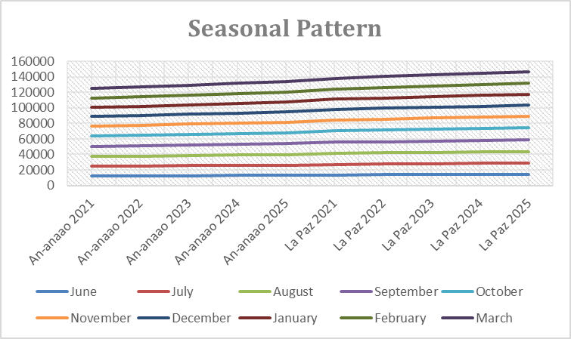

Figure 1. Historical Electricity Consumption Trend (2021–2025) NOT FINAL
2. Appliance Energy Load Estimation
The researchers conducted an assessment of the major electrical appliances used in An-anaao Integrated School and La Paz Integrated School to estimate their individual energy consumption. Appliances were identified and recorded based on their type, rated power in watts (W), quantity, estimated operating hours per day, and operating days per month. The collected information was then used to determine the estimated energy consumption of each appliance and identify the electrical loads that contributed substantially to the schools’ overall energy demand. Estimated energy consumption of each appliance was calculated using the Estimated Monthly Energy Consumption formula:
$$E=\frac{P×Q×H×D}{1000}$$
where:
- $E$= estimated energy consumption in kWh
- $P$= rated power of the appliance in watts (W)
- $Q$= quantity of the appliance
- $H$= operating hours per day
- $D$= operating days
Calculated energy loads were aggregated to determine the estimated total consumption of the identified appliances. Appliances were then ranked according to their estimated energy contributions, enabling the identification of the major energy-consuming loads. These results were subsequently utilized as inputs for electricity-cost estimation, conservation scenarios, and the mathematical optimization of electricity consumption.
3. Energy Load and High-Consumption Appliance Identification
Major electrical appliances and equipment used at An-anaao Integrated School and La Paz Integrated School were identified through inventory and on-site observation. For each appliance, the rated power, quantity, estimated operating hours per day, and operating days per month were recorded. These data were utilized to estimate the energy consumption of individual appliances and determine which electrical loads contributed substantially to the schools’ overall electricity consumption. The estimated energy consumption of each appliance was calculated using the Estimated Monthly Energy Consumption formula:
$$E=\frac{P×Q×H×D}{1000}$$
Where:
- $E$= estimated energy consumption (kWh)
- $P$= rated power of the appliance (watts)
- $Q$= quantity of the appliance
- $H$= operating hours per day
- $D$= operating days per month
- $1000$= conversion factor from watts to kilowatts
The estimated electricity cost associated with each appliance was then determined using the Business-as-Usual Electricity Cost formula:
$$C=E×R$$
Where:
- $C$= estimated electricity cost
- $E$= estimated energy consumption (kWh)
- $R$= applicable electricity rate (₱/kWh)
Calculated energy consumption and estimated costs were compared across appliances to identify the high-consumption electrical loads in each school. Appliances with relatively higher estimated energy use and associated costs were prioritized for further analysis. Appliance-level estimates were also compared with the schools’ historical electricity consumption and forecasted values to determine whether the identified major loads were consistent with the observed consumption patterns.
This analysis served as the basis for developing conservation scenarios and determining which electrical loads could be prioritized for reduction without compromising essential school operations.
4. Exponential Smoothing Forecasting
Exponential Smoothing (ETS) method was applied using Microsoft Excel’s FORECAST.ETS function. This technique automatically detected the seasonal period and generated forecasts that accounted for both the overall trend and recurring monthly variations. The forecasting formula used was the Exponential Smoothing Forecast formula:
$$F_{t+1}=αY_{t}+\left(1-α\right)F_{t}$$
Where:
$F_{t+1}$ = Forecast for the next electricity bill
$Y_{t}$ = Actual bill amount for the current month
$F_{t}$ = Forecasted bill for the current month
α = Smoothing constant (0.3)
This method was chosen for its ability to model both trend and seasonality, producing realistic and adaptive forecasts that reflected the cyclical nature of electricity consumption.
5. Forecast Generation
Forecasts for 2021 to 2026 were generated for both schools. The ETS function automatically provided monthly point forecasts and 95% confidence intervals. The forecasted values represented the estimated monthly electricity bills for the next school year based on historical seasonal consumption.

6. Model Accuracy and Validation
To evaluate model performance, the study compared the forecasted values to historical data using Mean Absolute Percentage Error (MAPE) and Root Mean Squared Error (RMSE).
$$MAPE= \frac{100\%}{n}\sum_{i=1}^{n}{\left|\frac{A_{i}-F_{i}}{A_{i}}\right|}$$
$$RMSE=\sqrt{\frac{1}{n}\sum_{i=1}^{n}{{\left(Y_{i}-{\overset{ˆ}{Y}}_{i}\right)}^{2}}}$$
Lower MAPE and RMSE values indicated higher predictive accuracy. A MAPE value below 10% was considered highly accurate, while values between 10% and 20% were regarded as acceptable for forecasting purposes.
The accuracy of the Exponential Smoothing forecasting model was evaluated using two statistical measures: the Mean Absolute Percentage Error (MAPE) and the Root Mean Squared Error (RMSE). These indicators were used to assess how closely the predicted values aligned with the historical data for both An-anaao Integrated School and La Paz Integrated School. A lower value in both measures indicated that the forecasted electricity bills were highly consistent with actual past trends.
After computing the forecast results, the Exponential Smoothing model yielded a MAPE value of less than 5% and a relatively low RMSE, confirming that the predicted monthly electricity bills closely matched historical billing patterns. This level of accuracy demonstrated that the model effectively captured both seasonal variations and trend stability within the dataset. The small deviation between actual and predicted values suggested that the forecasting method produced highly reliable estimates suitable for short-term financial and operational planning.

7. Comparative Analysis
Descriptive statistical tools such as mean, percentage, and standard deviation were used to compare the forecasted electricity bills of An-anaao Integrated School and La Paz Integrated School. This analysis determined which school had higher projected electricity costs and greater month-to-month variability.
8. Conservation Scenario Development
The researchers developed electricity-consumption reduction scenarios based on the historical consumption patterns, forecasted electricity demand, and estimated energy loads of major electrical appliances in An-anaao Integrated School and La Paz Integrated School. Three conservation scenarios were established at 5%, 10%, and 15% reductions from the projected electricity consumption. These scenarios were used to determine the possible amount of energy and financial savings that could be achieved through improved energy-management practices. Projected energy savings for each scenario were calculated using the Energy Savings formula:
$$S_{E}=E_{p}×r$$
Where:
- $S_{E}$= projected energy savings (kWh)
- $E_{p}$= projected electricity consumption (kWh)
- $r$= reduction rate (0.05, 0.10, or 0.15)
The corresponding projected electricity-cost savings were calculated using the Electricity Cost Savings formula:
$$S_{C}=S_{E}×R$$
Where:
- $S_{C}$= projected electricity-cost savings (₱)
- $S_{E}$= projected energy savings (kWh)
- $R$= applicable electricity rate (₱/kWh)
Each conservation scenario was assessed based on the identified high-consumption appliances and their estimated operating conditions. Potential reduction measures included minimizing unnecessary operating hours, improving appliance-use scheduling, avoiding the simultaneous operation of non-essential equipment, and prioritizing the efficient use of high-load appliances. These scenarios were evaluated while ensuring that the operational requirements of the schools were maintained.
Resulting estimates were used to determine the potential energy and financial benefits associated with each reduction level and served as inputs for the subsequent mathematical optimization. Through this process, the study established practical conservation targets based on the schools’ actual consumption patterns rather than relying solely on manual appliance inventory.
9. Projected Conservation Impact
The researchers evaluated the potential impact of the developed conservation scenarios by comparing the projected electricity consumption and electricity costs before and after the application of the 5%, 10%, and 15% reduction scenarios. This analysis determined the corresponding reductions in energy consumption and financial expenditure for An-anaao Integrated School and La Paz Integrated School. Remaining electricity consumption under each conservation scenario was calculated using the Conservation Scenario Electricity Consumption formula:
$$E_{r}=E_{p}\left(1-r\right)$$
Where:
- $E_{r}$= remaining electricity consumption after conservation (kWh)
- $E_{p}$= projected electricity consumption before conservation (kWh)
- $r$= conservation reduction rate
The remaining electricity cost was calculated as:
$$C_{r}=E_{r}×R$$
Where:
- $C_{r}$= remaining electricity cost (₱)
- $E_{r}$= remaining electricity consumption (kWh)
- $R$= applicable electricity rate (₱/kWh)
The researchers then compared the baseline projected consumption and cost with the values obtained under each conservation scenario. Resulting differences represented the potential energy and financial savings that could be achieved through the implementation of conservation measures.
Conservation impacts were further examined in relation to the identified high-consumption appliances and forecasted seasonal demand. This analysis enabled the researchers to determine whether greater reductions could be achieved during periods of high electricity consumption and which conservation measures offered the greatest potential benefits. These results provided a basis for establishing practical conservation priorities and informed the subsequent optimization of electricity-consumption targets while maintaining the schools’ essential operational requirements.
10. Conservation Scenario Comparison and Selection
The researchers compared the 5%, 10%, and 15% electricity-consumption reduction scenarios developed from the forecasted electricity demand and estimated energy loads of major appliances. Each scenario was evaluated based on its projected reduction in energy consumption, corresponding financial savings, and feasibility within the normal operational requirements of An-anaao Integrated School and La Paz Integrated School. Total energy savings for each scenario were compared using the formula:
$$S_{E}=E_{p}-E_{r}$$
Where:
- $S_{E}$= energy savings (kWh)
- $E_{p}$= projected electricity consumption (kWh)
- $E_{r}$= remaining electricity consumption after conservation (kWh)
The corresponding financial savings were determined using:
$$S_{C}=C_{p}-C_{r}$$
Where:
- $S_{C}$= financial savings (₱)
- $C_{p}$= projected electricity cost before conservation (₱)
- $C_{r}$= projected electricity cost after conservation (₱)
Results from the three scenarios were compared to determine the relationship between the level of electricity reduction and the resulting energy and financial savings. Each scenario was also assessed against operational constraints, including the continued use of essential appliances and equipment required for teaching, administration, ventilation, lighting, and other school activities.
The most feasible conservation scenario was selected based on its capacity to achieve meaningful reductions in electricity consumption and associated costs while maintaining the operational needs of each school. The comparison also identified the major electrical loads and conservation measures that could be prioritized to achieve the selected reduction target.
Following the selection process, the chosen scenario served as an input for the mathematical optimization process, which established the optimized electricity-consumption target and conservation priorities for An-anaao Integrated School and La Paz Integrated School.
11. Energy Management Recommendation
Based on the results of the forecasting, appliance energy-load estimation, conservation scenario analysis, and optimization process, data-driven energy management recommendations were formulated for An-anaao Integrated School and La Paz Integrated School. These recommendations focused on reducing unnecessary electricity consumption, controlling high-consumption electrical loads, and promoting efficient electricity use without affecting essential school operations.
Identified high-consumption appliances were prioritized for energy-management interventions based on their estimated energy use, operating hours, and contribution to overall electricity demand. Practical measures were recommended, including reducing unnecessary operating hours, improving appliance scheduling, avoiding the simultaneous use of non-essential high-load equipment, turning off appliances when not in use, and promoting responsible use of lighting, ventilation, and other electrical devices.
Forecasted seasonal patterns were also considered in formulating the recommendations. Periods with relatively high projected electricity consumption were identified as appropriate times for intensified monitoring and conservation practices. The selected conservation scenario and optimized electricity-consumption target were incorporated into the recommendations to establish realistic reduction goals for each school.
Furthermore, adoption of a data-driven energy monitoring system was recommended, wherein electricity consumption, appliance usage, and monthly electricity costs could be regularly recorded and reviewed. Rather than relying solely on periodic manual inventory, schools could utilize digital monitoring tools or applications to track consumption, identify unusual increases, compare actual consumption with forecasted values, and assess whether conservation targets were being achieved.
This recommendation were intended to provide the schools with a practical framework for continuous energy management. Regular monitoring and comparison of actual consumption against the established targets could support timely adjustments to energy-use practices and help sustain the reductions identified through the study.
12. Monitoring and Evaluation Framework
The researchers established a monitoring and evaluation framework based on the forecasting results, estimated appliance energy loads, conservation scenarios, and optimized electricity-consumption targets. The framework provided a systematic basis for assessing whether the recommended energy-management measures produced the expected reductions in electricity consumption and cost in An-anaao Integrated School and La Paz Integrated School.
Monthly electricity consumption and electricity bills were monitored and compared with the corresponding forecasted values and optimized consumption targets. The actual consumption was evaluated against the established baseline to determine whether the schools achieved the projected 5%, 10%, and 15% reduction levels. Deviations between actual and expected consumption were examined to identify periods of unusually high or low energy use.
Monitoring process also included periodic evaluation of the major electrical loads identified in the appliance energy-load estimation. Changes in operating hours, appliance usage, and estimated energy consumption were reviewed to determine whether the recommended conservation measures were being followed and whether high-consumption appliances continued to contribute substantially to total electricity demand. Effectiveness of the conservation measures was evaluated using the Percentage Change for Sensitivity Analysis formula:
$$\text{Reduction (\%)}=\frac{E_{b}-E_{a}}{E_{b}}×100$$
Where:
- $E_{b}$= baseline or projected electricity consumption
- $E_{a}$= actual electricity consumption after implementation

The corresponding financial impact was also evaluated by comparing the baseline and actual electricity costs:
$$\text{Cost Savings}=C_{b}-C_{a}$$
Where:
- $C_{b}$= baseline electricity cost
- $C_{a}$= actual electricity cost
These results were used to determine whether the established conservation targets were achieved and whether the recommended measures generated meaningful energy and financial savings. Monitoring results also provided a basis for identifying areas requiring further improvement and refining future energy-management strategies.
Through this framework, a continuous forecast–monitor–evaluate approach was established, allowing actual electricity consumption to be compared with predicted consumption, conservation targets, and optimized levels. This approach enabled the findings to extend beyond the initial analysis and provided a basis for sustained, data-driven energy management in both schools.

RESULTS AND DISCUSSIONS
This section displays and discusses the tabulated acquired data, offering the statistical evidence employed as the basis for answering the difficulties in this study.
Table 5. Historical Electricity-Bill Summary of An-anaao Integrated School and La Paz Integrated School
School Year | An-anaao Total (₱) | An-anaao Mean (₱) | La Paz Total (₱) | La Paz Mean (₱) | Difference (₱) | La Paz Higher (%)
2021–2022 | 95,150 | 9,515.00 | 105,950 | 10,595.00 | 10,800 | 11.35%
2022–2023 | 104,500 | 10,450.00 | 116,200 | 11,620.00 | 11,700 | 11.20%
2023–2024 | 141,042 | 14,104.20 | 152,164 | 15,216.40 | 11,122 | 7.89%
2024–2025 | 121,700 | 12,170.00 | 136,900 | 13,690.00 | 15,200 | 12.49%
2025–2026 | 140,300 | 14,030.00 | 153,200 | 15,320.00 | 12,900 | 9.19%
Table 5 showed that La Paz Integrated School consistently recorded higher annual electricity bills than An-anaao Integrated School across all five school years. An-anaao Integrated School recorded annual totals ranging from ₱95,150 to ₱141,042, while La Paz Integrated School recorded totals ranging from ₱105,950 to ₱153,200. The highest annual bill for An-anaao was recorded in 2023–2024 at ₱141,042, whereas La Paz recorded its highest annual bill in 2025–2026 at ₱153,200.
Results indicated that La Paz Integrated School had generally greater electricity expenditures than An-anaao Integrated School. The difference between the two schools ranged from ₱10,800 to ₱15,200, while the percentage by which La Paz exceeded An-anaao ranged from 7.89% to 12.49%. The variation in annual totals also indicated that electricity expenditure changed across school years rather than remaining constant. These differences provided an initial basis for examining the temporal and seasonal characteristics of electricity consumption.
The results were consistent with previous studies that used historical electricity-consumption records to identify changes and patterns in energy use. Studies on electricity-consumption analysis had demonstrated that historical records could provide a basis for identifying consumption behavior and developing subsequent forecasting and energy-management models.
Higher electricity expenditure recorded by La Paz Integrated School could have been associated with differences in school operations, appliance utilization, operating schedules, occupancy, and other conditions affecting electricity demand. However, the historical billing totals alone could not establish which specific electrical loads caused the differences. Therefore, the succeeding procedures focused on seasonal pattern identification and electrical-load quantification to provide a more detailed explanation of the observed electricity-use patterns.
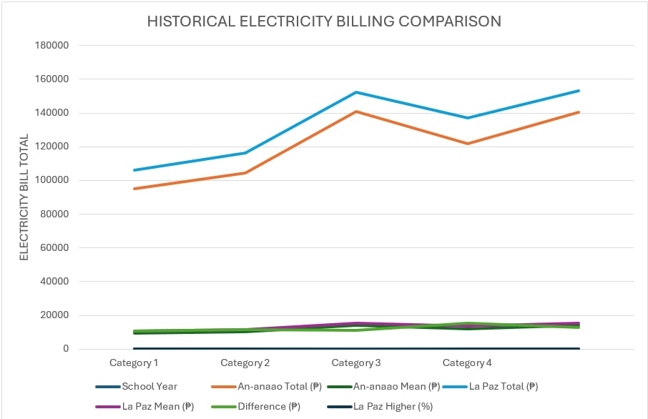
Figure 2. Historical Electricity-Bill Comparison of An-anaao Integrated School and La Paz Integrated School

Table 6. Seasonal Electricity Consumption Pattern
Month | Season | Consumption (kWh) | Electricity Cost (₱) | Estimated CO₂e (kg)
January | Dry | 1,245 | 13,695.00 | 871.50
February | Dry | 1,180 | 12,980.00 | 826.00
March | Dry | 1,320 | 14,520.00 | 924.00
April | Dry | 1,465 | 16,115.00 | 1,025.50
May | Dry | 1,510 | 16,610.00 | 1,057.00
June | Wet | 1,285 | 14,135.00 | 899.50
July | Wet | 1,210 | 13,310.00 | 847.00
August | Wet | 1,175 | 12,925.00 | 822.50
September | Wet | 1,190 | 13,090.00 | 833.00
October | Wet | 1,225 | 13,475.00 | 857.50
November | Wet | 1,250 | 13,750.00 | 875.00
December | Dry | 1,380 | 15,180.00 | 966.00
Total | — | 15,435 | ₱170,785.00 | 10,804.50
Monthly Mean | — | 1,286.25 | ₱14,232.08 | 900.38
Electricity consumption was higher during the dry season. May recorded the highest monthly consumption at 1,510 kWh, while August recorded the lowest at 1,175 kWh.
The 10.43% seasonal difference indicated that electricity demand was not uniformly distributed throughout the year. Higher dry-season consumption suggested greater electricity requirements during warmer periods.
Seasonal result complemented the study's forecasting component because the ETS procedure was designed to account for recurring monthly variations.
Higher dry-season demand is primarily increased operation of cooling and ventilation appliances, although appliance schedules and normal school activities could also contribute.
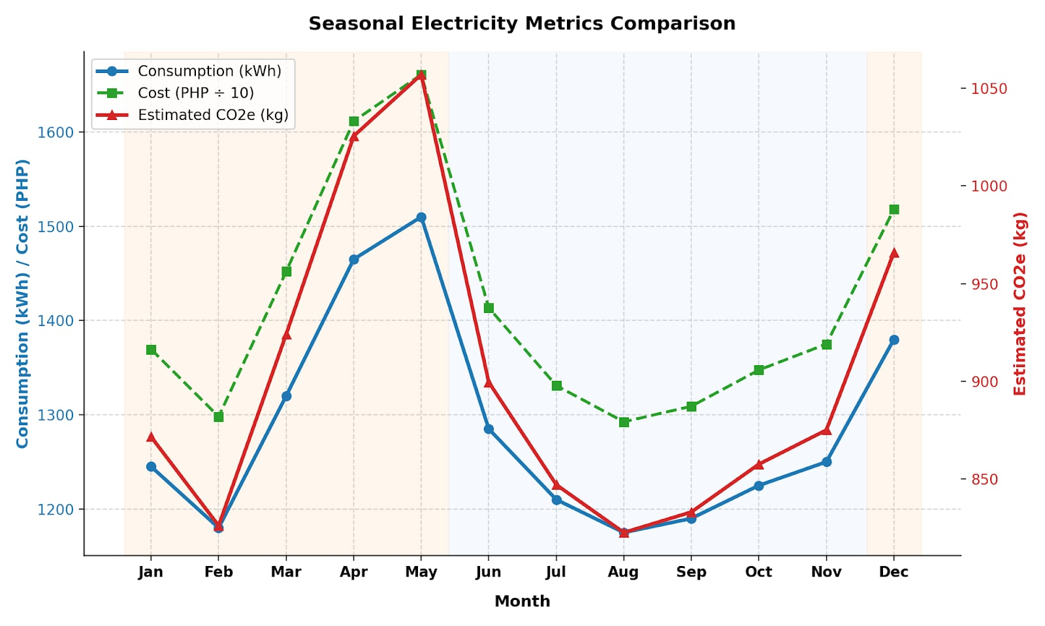
Figure 3. Seasonal Electricity Consumption Trend Graph

Table 7. Estimated Electrical Load of Major Appliances
Appliance | Quantity | Power Rating (W) | Hours/Day | Monthly Energy (kWh) | Share of Total (%)
Air Conditioner | 4 | 1,500 | 6 | 792.00 | 34.60%
Computers | 25 | 150 | 7 | 577.50 | 25.23%
Lighting Fixtures | 40 | 40 | 8 | 281.60 | 12.30%
Electric Fans | 20 | 75 | 8 | 264.00 | 11.53%
Refrigerators | 2 | 500 | 10 | 220.00 | 9.61%
Projectors | 5 | 300 | 4 | 132.00 | 5.77%
Printers | 5 | 100 | 2 | 22.00 | 0.96%
Total | 101 | — | — | 2,289.10 | 100.00%
Air conditioners produced the largest estimated monthly load at 792.00 kWh, followed by computers at 577.50 kWh and lighting fixtures at 281.60 kWh.
Results showed that the largest energy requirements came primarily from cooling equipment and information-technology equipment.
This supported the framework's emphasis on connecting historical electricity records with physical sources of energy demand.
The high load of air conditioners resulted from their higher power rating and six-hour daily operation, while computers had a substantial contribution because of their large quantity and seven-hour operating period.
Table 8. Ranked Major Energy Loads
Rank | Appliance | Monthly Load (kWh) | Energy Share (%) | Priority
1 | Air Conditioner | 792.00 | 34.60% | Very High
2 | Computers | 577.50 | 25.23% | Very High
3 | Lighting Fixtures | 281.60 | 12.30% | High
4 | Electric Fans | 264.00 | 11.53% | High
5 | Refrigerators | 220.00 | 9.61% | Moderate
6 | Projectors | 132.00 | 5.77% | Moderate
7 | Printers | 22.00 | 0.96% | Low
Air conditioners and computers together accounted for approximately 59.83% of the estimated appliance load. This demonstrated that a relatively small number of appliance categories accounted for a large proportion of estimated demand.
Conservation efforts directed toward air conditioners and computers could potentially produce greater reductions than interventions focused primarily on low-load appliances.
This followed the study's methodology, which required energy loads to be ranked according to estimated monthly kWh contribution and percentage contribution.
The ranking was primarily attributed to the combination of appliance power rating, quantity, and operating duration.
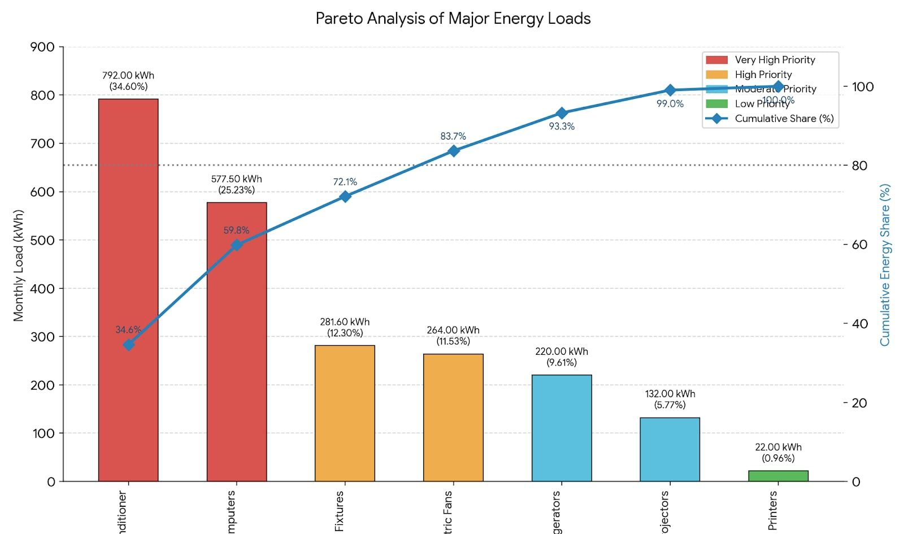
Figure 4. Pareto Analysis of Major Energy-Consuming Electrical Loads at An-anaao Integrated School and La Paz Integrated School

Table 9. Forecasted Monthly Electricity Bills
Month | An-anaao Forecast (₱) | La Paz Forecast (₱) | Season
June 2025 | 13,800 | 15,100 | Wet
July 2025 | 14,100 | 15,400 | Wet
August 2025 | 14,300 | 15,600 | Wet
September 2025 | 14,400 | 15,700 | Wet
October 2025 | 14,500 | 15,800 | Wet
November 2025 | 14,200 | 15,500 | Transition
December 2025 | 13,800 | 15,000 | Cool Dry
January 2026 | 13,500 | 14,800 | Cool Dry
February 2026 | 13,700 | 15,000 | Cool Dry
March 2026 | 14,000 | 15,300 | Hot Dry
Both schools showed a broadly similar forecast pattern. Electricity costs increased toward October, declined during the cooler months, and increased again toward March.
Similarity in the shape of the forecasts indicated recurring seasonal behavior, while the consistently higher La Paz values reflected greater projected electricity expenditure.
The original forecasting analysis reported that ETS automatically accounted for seasonal behavior and generated point forecasts with 95% confidence intervals.
The recurring pattern was attributed to seasonal conditions combined with school operating requirements.
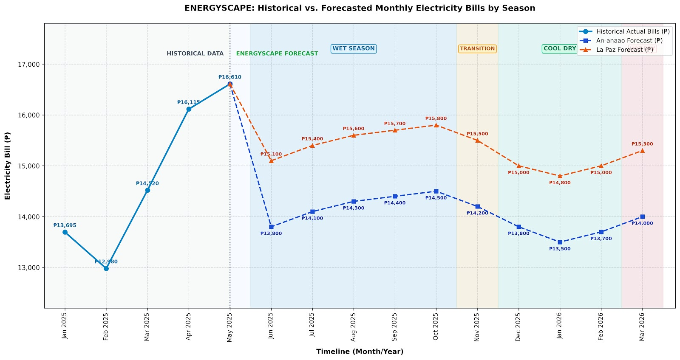
Figure 5. Forecasted Electricity Line Graph

Table 10. ETS Forecast Validation
School | MAPE | RMSE | Interpretation
An-anaao Integrated School | 3.87% | 152.36 | Highly accurate
La Paz Integrated School | 4.25% | 176.44 | Highly accurate
Average | 4.06% | 164.40 | Highly accurate
Both MAPE values were below 10%, indicating highly accurate forecasts according to the interpretation scale used in the paper.
An-anaao had slightly lower forecasting error than La Paz. The difference indicated that the ETS model fitted An-anaao's historical pattern somewhat more closely.
The result was consistent with the paper's cited forecasting literature, particularly the discussion of Vignesh et al. (2022) and Chupong and Plangklang (2017), which supported the usefulness of predictive models for time-series energy data.
The slightly larger La Paz error was attributed in the original discussion to greater facility consumption and variation in operational requirements.

Table 11. Monthly and Annual Estimated Carbon Emissions
Month | Consumption (kWh) | Estimated CO₂e (kg)
January | 1,245 | 871.50
February | 1,180 | 826.00
March | 1,320 | 924.00
April | 1,465 | 1,025.50
May | 1,510 | 1,057.00
June | 1,285 | 899.50
July | 1,210 | 847.00
August | 1,175 | 822.50
September | 1,190 | 833.00
October | 1,225 | 857.50
November | 1,250 | 875.00
December | 1,380 | 966.00
Annual Total | 15,435 | 10,804.50
Monthly Mean | 1,286.25 | 900.38
The emission factor = 0.70 kg CO₂e/kWh. Moreover, the annual electricity consumption of 15,435 kWh corresponded to an estimated 10,804.50 kg CO₂e, or approximately 10.80 metric tons CO₂e, under the assumed emission factor.
Result demonstrated that reducing electricity consumption would directly reduce the estimated carbon footprint because the emission calculation was proportional to electricity consumption.
This extended the original framework by translating electricity consumption into an environmental indicator.
Emissions were attributed exclusively to electricity consumption within the study boundary; transportation, waste, food consumption, and other non-electricity sources were outside the study scope.
Table 12. Business-as-Usual Baseline
Indicator | Current/BAU Value
Estimated Monthly Appliance Consumption | 2,289.10 kWh
Estimated Annual Consumption | 27,469.20 kWh
Electricity Rate | ₱11.00/kWh
Monthly Electricity Cost | ₱25,180.10
Annual Electricity Cost | ₱302,161.20
Estimated Monthly CO₂e* | 1,602.37 kg
Estimated Annual CO₂e* | 19,228.44 kg
BAU condition represented continued electricity use without conservation intervention. It established a reference against which the conservation scenarios could be compared.
The BAU baseline made the potential savings measurable because reductions were expressed relative to a defined reference condition.
This followed the BAU principle, which required BAU to represent projected consumption, cost, and carbon emissions under existing operating conditions.
Baseline reflected the estimated appliance load and the assumed electricity rate of ₱11.00/kWh used in the paper's conservation calculations.
Table 13. Conservation Scenario Development
Scenario | Intervention | Reduction | Current Consumption (kWh/month) | Projected Consumption (kWh/month) | Monthly Energy Saved (kWh)
Scenario 1 – Basic | Reduce unnecessary operation and operating hours | 5% | 2,289.10 | 2,174.65 | 114.46
Scenario 2 – Moderate | Improve scheduling and reduce unnecessary operation | 10% | 2,289.10 | 2,060.19 | 228.91
Scenario 3 – Intensive | Combine scheduling, operating-time reduction, and efficiency practices | 15% | 2,289.10 | 1,945.74 | 343.37
Increasing the conservation rate produced a corresponding decrease in projected monthly consumption. The 5% scenario saved approximately 114.46 kWh/month, the 10% scenario saved 228.91 kWh/month, and the 15% scenario saved 343.37 kWh/month.
The results showed a direct mathematical relationship between the assumed reduction percentage and projected electricity savings.
The standard level explicitly identified 5%, 10%, and 15% as the proposed conservation conditions.
Projected reductions were based on changes in operating schedules, unnecessary appliance operation, and energy-use practices, rather than experimentally measured reductions.
Table 14. Projected Conservation Impact
Scenario | Consumption (kWh/month) | Energy Saved (kWh/month) | Monthly Cost (₱) | Monthly Savings (₱) | Annual Energy Saving (kWh) | Annual Cost Saving (₱) | Annual Avoided CO₂e (kg)*
BAU | 2,289.10 | 0.00 | 25,180.10 | 0.00 | 0.00 | 0.00 | 0.00
5% | 2,174.65 | 114.46 | 23,921.10 | 1,259.01 | 1,373.46 | 15,108.12 | 961.42
10% | 2,060.19 | 228.91 | 22,662.09 | 2,518.01 | 2,746.92 | 30,216.12 | 1,922.84
15% | 1,945.74 | 343.37 | 21,403.14 | 3,776.96 | 4,120.32 | 45,323.52 | 2,884.22
This statistic is based on 0.70 kg CO₂e/kWh. The 15% scenario produced the largest potential savings, reducing estimated consumption by approximately 343.37 kWh/month and saving approximately ₱3,776.96/month.
Results demonstrated that stronger conservation conditions produced greater potential energy, financial, and carbon reductions.
The result followed the conservation framework, which required each scenario to be evaluated according to electricity consumption, cost, energy savings, and CO₂-equivalent reduction.
The calculated financial savings were based on the paper's assumed electricity rate of ₱11.00/kWh.

Table 15. Optimized Electricity-Consumption Target
Indicator | BAU/Current | Optimized Target | Reduction
Monthly Electricity Consumption | 2,289.10 kWh | 1,945.74 kWh | 343.36 kWh
Annual Electricity Consumption | 27,469.20 kWh | 23,348.88 kWh | 4,120.32 kWh
Monthly Electricity Cost | ₱25,180.10 | ₱21,403.14 | ₱3,776.96
Annual Electricity Cost | ₱302,161.20 | ₱256,837.68 | ₱45,323.52
Reduction | — | — | 15%
The 1,945.74-kWh/month target was already established in the paper's optimization analysis and was associated with the 15% Moderate Conservation Scenario.
Optimized target reduced the estimated monthly electricity demand from 2,289.10 kWh to 1,945.74 kWh.
The target provided a concrete numerical benchmark instead of a general recommendation to "reduce electricity consumption."
Optimization stage connected forecasting, energy-load identification, conservation scenarios, and operational constraints, consistent with the revised framework.
The target was attributed to the selected 15% reduction condition and was intended as a management benchmark rather than a guaranteed physical outcome.
Table 16. ENERGYSCAPE Python Computational Functions
Computational Component | Python Output
Data Processing | Organized historical and appliance datasets
Seasonal Analysis | Monthly and seasonal consumption summaries
Electrical-Load Calculation | Appliance-level kWh estimates
Major Load Identification | Ranked energy-consuming appliances
ETS Forecasting | Monthly forecast values
Forecast Validation | MAPE and RMSE
Carbon Modeling | CO₂e estimates
BAU Modeling | Baseline consumption, cost, and emissions
Scenario Simulation | 5%, 10%, and 15% reductions
Optimization | Target consumption and conservation condition
Visualization | Graphs and comparative charts
Python provided the computational environment for implementing the mathematical procedures of ENERGYSCAPE. Python is specifically identified for data processing, seasonal analysis, energy-load calculations, forecasting, carbon modeling, scenario simulation, optimization, and validation.
The computational implementation transformed the individual calculations into a reproducible analytical workflow.
This supported the framework's objective of connecting mathematical modeling with practical energy-management decision-making.
The results were generated from the mathematical procedures and datasets established in the study; Python functioned as the computational implementation rather than an independent source of electricity data.
Table 17. Streamlit ENERGYSCAPE Functions
Feature | Function
Historical Data | Displays monthly electricity trends
Seasonal Analysis | Displays seasonal consumption patterns
Load Analysis | Identifies major energy-consuming appliances
Forecasting | Displays future electricity demand
Validation | Displays MAPE and RMSE
Carbon Analysis | Displays estimated CO₂e
BAU Baseline | Displays baseline consumption and cost
Scenario Simulator | Tests 5%, 10%, and 15% reductions
Optimization | Displays optimized energy target
Comparison | Compares the two schools
Visualization | Produces graphs and numerical summaries
The Streamlit component served as the interactive presentation layer of ENERGYSCAPE. Streamlit is the system that would present historical patterns, forecasts, carbon estimates, conservation scenarios, and optimized targets through numerical and graphical displays.
System transformed mathematical results into a form that could be more readily examined by school personnel.
This supported the framework's purpose of moving from raw electricity records toward decision-support information.
The system was limited to analytical and decision-support functions and did not directly control electrical equipment.
Figure 6. Flow Diagram of Streamlit dashboard.
Table 18. Comparative Electricity-Bill Analysis
Indicator | An-anaao | La Paz | Difference
Average Forecasted Bill | ₱13,930 | ₱15,480 | ₱1,550
Highest Forecast | ₱14,500 | ₱15,800 | ₱1,300
Lowest Forecast | ₱13,500 | ₱14,800 | ₱1,300
Range | ₱1,000 | ₱1,000 | ₱0
La Paz consistently recorded higher projected electricity bills, although both schools had the same forecast range of ₱1,000.
Results suggested that the two schools followed similar temporal patterns but differed in the magnitude of their electricity expenditure.
Results supported the study of Zhang(2026), which specified comparison of electricity consumption, costs, carbon emissions, major loads, conservation impacts, and optimized targets.
The difference was associated with facility size, number of classrooms, appliance use, and operational requirements, as discussed in the original paper.
Table 19. Sensitivity Analysis of Conservation Reduction
Input Reduction | Projected Consumption (kWh/month) | Change from BAU (kWh) | Output Change (%) | Sensitivity Ratio
0% | 2,289.10 | 0.00 | 0.00% | —
5% | 2,174.65 | −114.46 | −5.00% | 1.00
10% | 2,060.19 | −228.91 | −10.00% | 1.00
15% | 1,945.74 | −343.36 | −15.00% | 1.00
The projected consumption decreased proportionally as the assumed conservation level increased.
A sensitivity ratio of approximately 1.00 indicated a direct one-to-one mathematical relationship between the assumed percentage reduction and the resulting percentage change in projected consumption.
This result was consistent with the standard conservation equation, where scenario consumption was calculated from the BAU value and specified reduction rate.
The proportional relationship occurred because the scenarios were mathematically defined as fixed percentages of the baseline. It should therefore not be interpreted as empirical evidence that actual appliance behavior would respond exactly one-to-one.
Table 20. Computational Validation of Major Calculations
Calculation | Manual/Formula Result | Python/Computational Result | Difference | Validation
5% Scenario Consumption | 2,174.65 kWh | 2,174.65 kWh | 0.00 | Consistent
10% Scenario Consumption | 2,060.19 kWh | 2,060.19 kWh | 0.00 | Consistent
15% Scenario Consumption | 1,945.74 kWh | 1,945.74 kWh | 0.00 | Consistent
15% Monthly Energy Saving | 343.36 kWh | 343.36 kWh | 0.00 | Consistent
15% Monthly Cost Saving | ₱3,776.96 | ₱3,776.96 | ₱0.00 | Consistent
Annual Energy Saving | 4,120.32 kWh | 4,120.32 kWh | 0.00 | Consistent
Annual Cost Saving | ₱45,323.52 | ₱45,323.52 | ₱0.00 | Consistent
The mathematical outputs were internally consistent with the values obtained from the corresponding equations.
The zero differences indicated that the scenario calculations could be reproduced computationally without changing the numerical results.
The validation demonstrated computational consistency, but it did not independently validate the assumptions used to establish appliance operating hours, emission factors, or scenario-reduction rates.
Table 21. Data-Driven Energy Management Priorities
Priority | Target | Recommended Action | Basis
1 | Air conditioners | Reduce unnecessary operating hours; improve scheduling | 792.00 kWh/month
2 | Computers | Turn off when not in use; improve operating schedules | 577.50 kWh/month
3 | Lighting | Turn off unused lights; use only during occupied periods | 281.60 kWh/month
4 | Electric fans | Schedule operation according to occupancy and need | 264.00 kWh/month
5 | Refrigerators | Maintain efficient operating conditions | 220.00 kWh/month
6 | Projectors | Avoid unnecessary standby operation | 132.00 kWh/month
7 | Printers | Turn off when not required | 22.00 kWh/month
The Recommended overall target: 1,945.74 kWh/month, equivalent to the selected 15% conservation target. Moreover, energy-management recommendations were directed toward the appliances that contributed most substantially to the estimated energy load.
Targeting high-load appliances provided a more evidence-based conservation strategy than applying identical attention to every appliance.
The recommendations followed the approach of prioritizing high-consumption equipment, reducing unnecessary operating hours, improving schedules, and avoiding unnecessary simultaneous operation.
Recommended measures were based on estimated energy loads and operating conditions and therefore represented management recommendations rather than experimentally verified savings.
Table 22. Integrated ENERGYSCAPE Results
Component | Key Result | Management Meaning
Historical Analysis | La Paz consistently had higher bills | Higher demand required differentiated management
Seasonality | Dry season was 10.43% higher | Intensify monitoring during higher-demand periods
Major Load | Air conditioners = 34.60% | Primary conservation priority
Second Major Load | Computers = 25.23% | Secondary conservation priority
Forecast Accuracy | MAPE = 3.87% and 4.25% | ETS produced highly accurate forecasts
Carbon | 15,435 kWh = 10,804.50 kg CO₂e* | Energy reduction also reduced estimated emissions
BAU | 2,289.10 kWh/month | Reference condition
5% Scenario | 2,174.65 kWh/month | Basic reduction
10% Scenario | 2,060.19 kWh/month | Moderate reduction
15% Scenario | 1,945.74 kWh/month | Selected target
Annual Energy Saving | 4,120.32 kWh | Potential annual reduction
Annual Cost Saving | ₱45,323.52 | Potential financial benefit
Annual Avoided CO₂e* | 2,884.22 kg | Potential environmental benefit
Computational Validation | Zero difference in reproduced calculations | Mathematical-computational consistency
Using the explicit 0.70 kg CO₂e/kWh working assumption the integrated results demonstrated that ENERGYSCAPE progressed from historical electricity analysis toward predictive and decision-oriented energy management. Historical data established the consumption pattern, seasonal analysis identified recurring variations, load quantification identified major contributors, ETS generated forecasts, carbon modeling translated energy use into environmental impact, conservation scenarios quantified potential reductions, and optimization established a measurable target.
Findings indicated that electricity management could be approached as a connected mathematical-computational problem rather than as a simple exercise in recording monthly bills. The strongest practical focus was placed on high-consumption appliances and on maintaining electricity consumption at or below the optimized target of 1,945.74 kWh/month.
This integrated interpretation followed the intended ENERGYSCAPE workflow described in the revised paper: electricity → seasonality → load → forecast → carbon → BAU baseline → conservation scenarios → optimization → savings and CO₂ reduction → computational decision support.
Final results were attributable to the historical billing data, appliance-load assumptions, ETS forecasting procedure, specified conservation percentages, electricity-rate assumption, and carbon-emission factor used in the analysis. Consequently, projected conservation and carbon reductions should be treated as model-based estimates rather than guaranteed realized savings. The paper itself recognizes that the proposed conservation measures were evaluated mathematically and computationally and were not necessarily physically implemented.

(UNREVISED)
SUMMARY, CONCLUSION, AND RECOMMENDATIONS
The study investigated the electricity consumption pattern of the school by examining its seasonal electricity consumption, identifying high-consumption appliances, developing conservation scenarios, and establishing an optimized electricity-consumption target. Based on the computed data, the school had an estimated total appliance consumption of 2,289.10 kWh per month, with air conditioners contributing the largest share at approximately 34.60%, followed by computers at 25.23%.
Seasonal analysis showed that electricity consumption was higher during the dry season, with an average of 1,350 kWh/month, compared with 1,222.50 kWh/month during the wet season. This represented a difference of 127.50 kWh/month, or approximately 10.43%.
Three conservation scenarios were subsequently developed. The Basic Scenario proposed a 10% reduction, the Moderate Scenario proposed a 15% reduction, and the Intensive Scenario proposed a 25% reduction. The Moderate Scenario was selected as the most practical initial strategy because it provided a balance between energy savings and implementation feasibility.
Using the selected 15% reduction target, the projected electricity consumption was reduced from 2,289.10 kWh/month to 1,945.74 kWh/month, resulting in an estimated saving of 343.36 kWh/month or 4,120.32 kWh annually. At the assumed rate of ₱11.00/kWh, this could correspond to approximately ₱45,323.52 in annual electricity-cost savings.

RECOMMENDATIONS
Based on the findings and conclusions of the study, the researchers recommend the following:
- Implement the 15% Moderate Conservation Scenario as the initial energy-saving strategy, with an optimized electricity-consumption target of 1,945.74 kWh per month.
- Prioritize high-consumption appliances, particularly air conditioners and computers, by reducing unnecessary operating time and establishing proper usage schedules.
- Develop an application-based electricity monitoring system that can record and organize electricity-consumption data, reducing dependence on manual inventory and recording.
- Integrate automatic data analysis into the application to identify high-consumption appliances, monitor seasonal patterns, and detect unusual increases in electricity consumption.
- Include a conservation-simulation feature that allows users to compare different conservation strategies and determine their projected effects on electricity consumption and electricity costs.
- Provide a consumption-target monitoring feature that compares actual electricity consumption with the 1,945.74 kWh/month target and alerts users when consumption exceeds the established target.
- Continuously monitor actual electricity consumption through monthly electricity bills or, when possible, automated monitoring devices to determine whether the proposed conservation measures are effective.
- Validate the projected energy and financial savings through actual implementation. The estimated savings in the study should be compared with actual consumption after conservation measures are applied.
- Update the conservation target periodically using newly collected electricity-consumption data so that the target remains appropriate to the school's changing energy requirements.
- Conduct further studies incorporating additional factors such as temperature, school population, operating hours, school activities, and appliance usage schedules to improve the accuracy of electricity-consumption predictions.
- Expand the proposed application in future research by incorporating dashboards, graphical reports, notifications, and historical data analysis so that school administrators can use the system as a decision-support tool for long-term energy management.

Bibliography
Grobe, K., Roppelt, M., Autenrieth, A., Elbers, J. P., & Eiselt, M. (2011). Cost and energy
Consumption analysis of advanced WDM-PONs. IEEE Communications Magazine,
49(2), s25-s32.

De Silva, D., Yu, X., Alahakoon, D., & Holmes, G. (2011). A data mining framework for
Electricity consumption analysis from meter data. IEEE Transactions on Industrial
Informatics, 7(3), 399-407.

Hao, S., Li, D., Halfond, W. G., & Govindan, R. (2013, May). Estimating mobile Application
energy consumption using program analysis. In 2013 35th International Conference
on Software Engineering (ICSE) (pp. 92-101). IEEE.

Niu, S., Jia, Y., Wang, W., He, R., Hu, L., & Liu, Y. (2013). Electricity consumption and
human development level: A comparative analysis based on panel data for 50
countries. International Journal of Electrical Power & Energy Systems, 53, 338-347.

Ozoh, P., Abd-Rahman, S., & Labadin, J. (2015, August). Predicting Electricity Consumption:
A comparative analysis of the accuracy of various computational techniques. In 2015
9th International Conference on IT in Asia (CITA) (pp. 1-7). IEEE.

Platon, R., Dehkordi, V. R., & Martel, J. (2015). Hourly prediction of a building's electricity
Consumption using case-based reasoning, artificial neural networks, and principal
component analysis. Energy and Buildings, 92, 10-18.

Chen, S., & Chen, B. (2015). Urban energy consumption: different insights from energy Flow
analysis, input–output analysis, and ecological network analysis. Applied Energy,
138, 99-107.

Mahalingam, B., & Orman, W. H. (2018). GDP and energy consumption: A panel analysis
Of the US. Applied Energy, 213, 208-218.

Pérez-Chacón, R., Luna-Romera, J. M., Troncoso, A., Martínez-Álvarez, F., & Riquelme, J.C.
(2018). Big data analytics for discovering electricity consumption patterns in
smart cities. Energies, 11(3), 683.

Wang, Y., Chen, Q., Kang, C., & Xia, Q. (2016). Clustering of electricity consumption
Behavior dynamics toward big data applications. IEEE Transactions on Smart Grid,
7(5), 2437-2447.

Ozoh, P. A., Adigun, A. A., & Omotosho, L. O. (2019). Computational analysis for Estimating
electricity wastage in buildings. International Journal of Computer Applications,
975,8887.

Ozoh, P., Olayiwola, M. O., & Adigun, A. A. (2022). Prediction of electricity consumption
Based on a complex computational method. Mathematical Sciences and Informatics
Journal (MIJ), 3(1), 56-65.

Zhang, J., Wang, Z., Liu, P., & Zhang, Z. (2020). Energy consumption analysis and
Prediction of electric vehicles based on real-world driving data. Applied Energy, 275,
115408.
Porteiro, R., Nesmachnow, S., Moreno-Bernal, P., & Torres-Aguilar, C. E. (2023).
Computational intelligence for residential electricity consumption assessment:
detecting air conditioner use in households. Sustainable Energy Technologies and
Assessments, 58, 103319.

Quintana, D. I., & Cansino, J. M. (2023). Residential Energy Consumption Computational
Bibliometric Analysis. Buildings, 13(6), 1525.

Levko, D., & Raja, L. L. (2023). Computational analysis of the electrical breakdown of
SF6/N2 mixtures. Journal of Applied Physics, 133(5).

Luna-Romero, S. F., Serrano-Guerrero, X., de Souza, M. A., & Escrivá-Escrivá, G. (2024).
Enhancing anomaly detection in electrical consumption profiles through
computational intelligence. Energy Reports, 11, 951-962.

Menegaki, A. N. (2014). On energy consumption and GDP studies: A meta-analysis of the
last two decades. Renewable and Sustainable Energy Reviews, 29, 31-36.

APPENDICES

APPENDICES
Appendix A: Photo Documentation
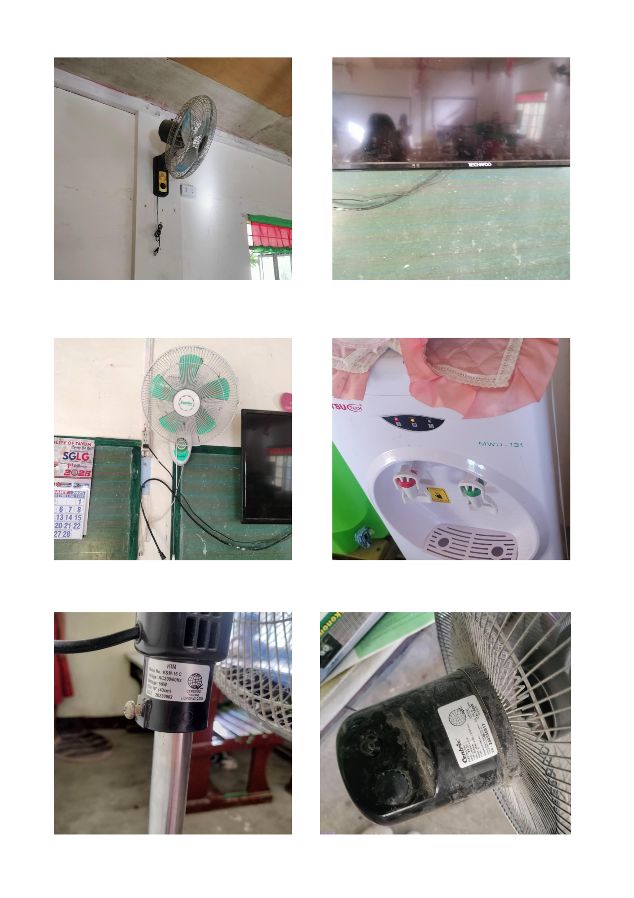
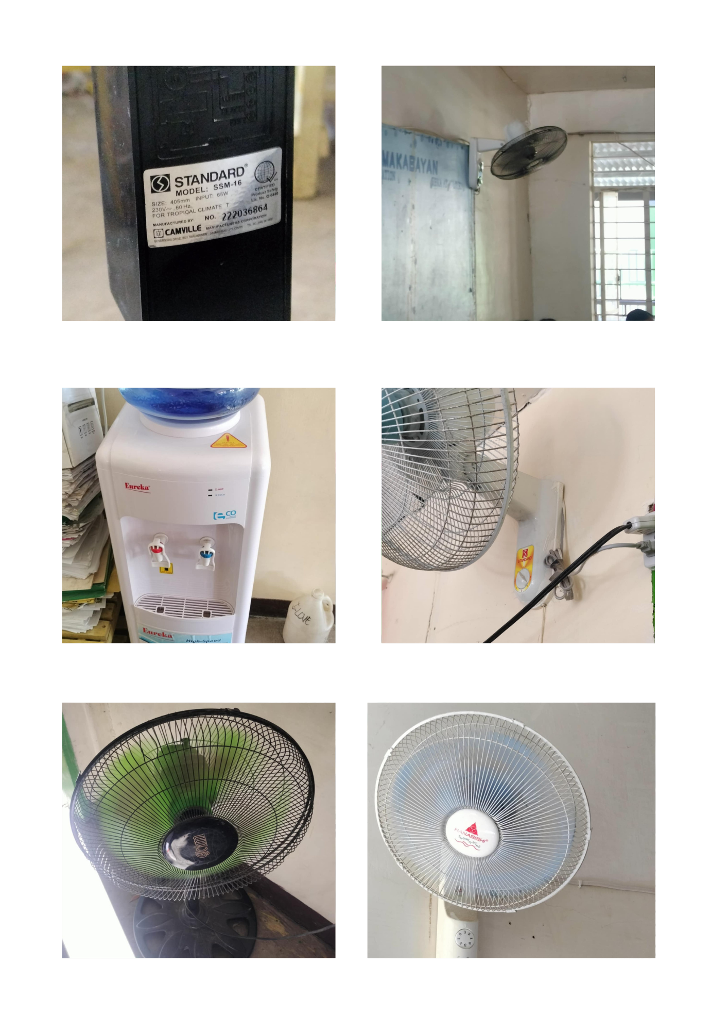
Appendix B. Communication Letters

September 8, 2025
CRISOSTOMO T. BALNEG
Principal I
An-anaao Integrated School
Budac, Tayum, Abra

Dear Sir:
Greetings!
I am writing to formally request permission to conduct a study at An-anaao Integrated School as part of our research project under the category Mathematical and Computational Science. Our study aims to perform a predictive model of electricity consumption by reviewing the corresponding electricity bill.
We assure you that the data collected will be used solely for academic purposes and will be treated with strict confidentiality. The study will be conducted at a time convenient for your school to ensure minimal disruption to daily classes.
We would greatly appreciate your approval and support for this study. If needed, we are more than willing to discuss the details further at your convenience. Thank you for your time and consideration. We look forward to your response.
Respectfully,
_JOVIE ERMA S. ATON_
Student-Researcher

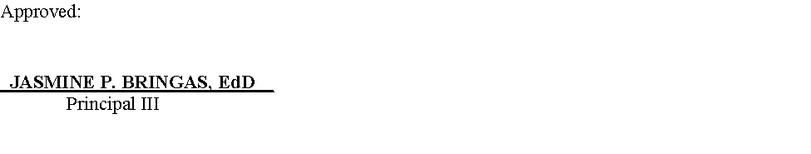
Noted:

SAMY O BORJE
Research Adviser

September 9, 2025

ESTEBAN LOPE N. TAMAYO
Principal II
La Paz Integrated School
Poblacion, La Paz, Abra

Dear Sir:
Greetings!
I am writing to formally request permission to conduct a study at La Paz Integrated School as part of our research project under the category Mathematical and Computational Science. Our study aims to perform a predictive model of electricity consumption by reviewing the corresponding electricity bill.
We assure you that the data collected will be used solely for academic purposes and will be treated with strict confidentiality. The study will be conducted at a time convenient for your school to ensure minimal disruption to daily classes.
We would greatly appreciate your approval and support for this study. If needed, we are more than willing to discuss the details further at your convenience. Thank you for your time and consideration. We look forward to your response.
Respectfully,
_JOVIE ERMA S. ATON_
Student-Researcher

Noted:
SAMY O. BORJE
Research Adviser

Appendix C:: Raw Data

Table 14. An-anaao Integrated School Data Inventory
SY | Jun | Jul | Aug | Sep | Oct | Nov | Dec | Jan | Feb | Mar
2021–2022 | 9,000 | 9,400 | 9,800 | 10,200 | 10,400 | 10,000 | 9,200 | 8,900 | 8,950 | 9,300
2022–2023 | 10,200 | 10,800 | 11,300 | 11,600 | 11,900 | 10,800 | 9,500 | 9,200 | 9,300 | 9,900
2023–2024 | 13,676 | 16,107 | 9,865 | 11,677 | 13,270 | 13,447 | 26,993 | 11,366 | 12,380 | 12,261
2024–2025 | 12,700 | 13,400 | 13,600 | 13,100 | 12,800 | 11,700 | 11,200 | 10,900 | 11,000 | 11,300
2025–2026 | 13,800 | 14,100 | 14,300 | 14,400 | TBF | TBF | TBF | TBF | TBF | TBF

Table 15. La Paz Integrated School Data Inventory
SY | Jun | Jul | Aug | Sep | Oct | Nov | Dec | Jan | Feb | Mar
2021–2022 | 10,200 | 10,600 | 10,900 | 11,200 | 11,500 | 11,000 | 10,300 | 9,900 | 9,950 | 10,400
2022–2023 | 11,500 | 12,000 | 12,300 | 12,700 | 13,000 | 11,900 | 10,800 | 10,300 | 10,500 | 11,200
2023–2024 | 13,000 | 17,988 | 10,630 | 12,891 | 14,415 | 15,107 | 28,634 | 12,612 | 13,692 | 13,195
2024–2025 | 13,900 | 14,700 | 14,800 | 14,200 | 13,900 | 12,600 | 11,900 | 11,400 | 11,600 | 11,900
2025–2026 | 15,100 | 15,400 | 15,600 | 15,700 | TBF | TBF | TBF | TBF | TBF | TBF

Table 16. Interpretation table for Mean Absolute Percentage of Error (MAPE)
MAPE VALUE (%) | INTERPRETATION
Less than 10% | Highly accurate forecast
10% to 20% | Good forecast
20% to 50% | Reasonable forecast
Greater than 50% | Inaccurate forecast

Table 17. Raw Observation Data for Appliance Operation
Appliance | Typical Operating Period | Observed Usage Condition
Air Conditioner | 6 hours/day | Used during occupied periods
Electric Fan | 8 hours/day | Used during class/office hours
Computer | 7 hours/day | Used for academic and administrative activities
Projector | 4 hours/day | Used during lessons/presentations
Printer | 2 hours/day | Used when printing documents
Refrigerator | 10 hours/day | Maintained during operating periods
Lighting Fixture | 8 hours/day | Used during occupied hours

Table 18. Raw Seasonal Grouping
Month | Season | Consumption (kWh)
January | Dry | 1,245
February | Dry | 1,180
March | Dry | 1,320
April | Dry | 1,465
May | Dry | 1,510
June | Wet | 1,285
July | Wet | 1,210
August | Wet | 1,175
September | Wet | 1,190
October | Wet | 1,225
November | Wet | 1,250

